Finding it hard to keep track of what's been happening at the salon?
Paper work getting you down?
Our super-simple system will save you hours of work
You are losing customers & money and another salon is stealing them
How?
They are sending them special offers on their e-mail and mobile phone

Dear fellow hair & beauty enthusiast,
I'm a business owner just like you, but I know computers and they are crucial in making your life easier. Our Intelligent Till and Customer Database is simply easy to use, we have no hidden setup costs and view supporting your needs as most important.
The Intelligent Till and Customer Database keep contact details, appointment book, stock control and even profiles customer buying patterns, as well as allows very easy postal, e-mail and text message marketing. Please don't buy a confusing, complex, grey and boring system, you are wasting your precious time, and you will have a nightmare training new staff.
Make it easy on yourself with Platinum....simply easy to use.
At the back of this pack is a 15 minute Home-DVD demo of an example business, helping you to easily experience our systems features. If you like what you see you can put this same disk into your computer to use it straight away and be making a huge difference today!
If you do not have internet your temporary license is on the disk (License.exe)
Platinum is compatible with most retail situations and service industries:
Hair, Beauty, Nail, Spa, Sunbed, Training College, Pharmacy, Hotel, Restaurant, Dentists, Doctors, Hardware, Public Houses & Training Colleges. Coming soon “Platinum for Schools and Nurseries”.
It’s simply easy to use and gives you great value for money.
Welcome to the family!

The Platinum Team

Platinum, an intelligent computer system especially designed to help your business keep & increase its customers
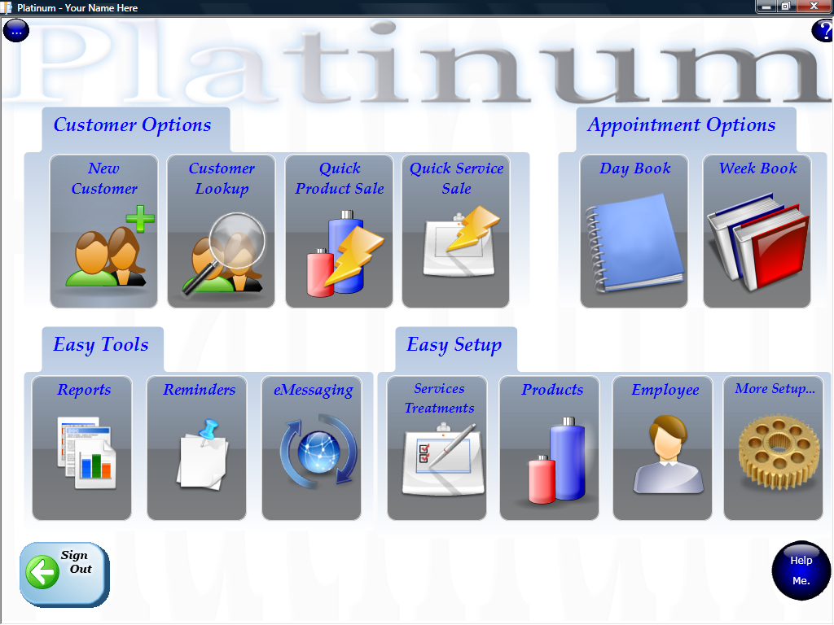
Platinum allows you to record customer information including phone contacts, email address, date of birth, courses and even loyalty points.
Platinum records each visit a customer makes, keeping information about the purchased products & services, employee and results allowing quick & easy access to this information when the customer next visits you. Each sale updates stock for stock control reports meaning fast reordering.
Platinum gives you the power to automatically send impressive email and text message marketing to customer groups, e.g. if they have not visited you within a certain amount of time.
Platinum enables you to automatically send text message reminders to customer mobile phones one or more days before the appointment to reduce no-shows and lateness. Customers can reply to these messages saying Yes or No(two-way) If ‘No’ you get an email and the appointment goes red in the electronic daybook diary to free it for someone else.
Each customer has a profile…
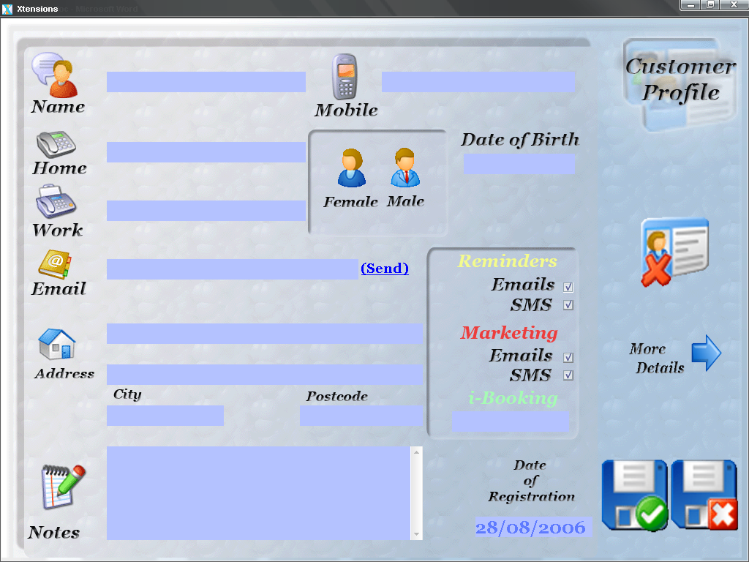
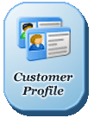
Customer personal details are entered into their Customer Profile screen (below).
Details recorded are:
- Name
- Home, work & mobile numbers
- Address
- Date of birth
- Date of registration
- Where the customer heard about you for effective marketing knowledge
- Courses and Loyalty values
- Any other notes e.g. ‘This customer likes to play tennis, has two children’

You can also choose how customers receive appointment reminders and e-marketing material - via text message or email!
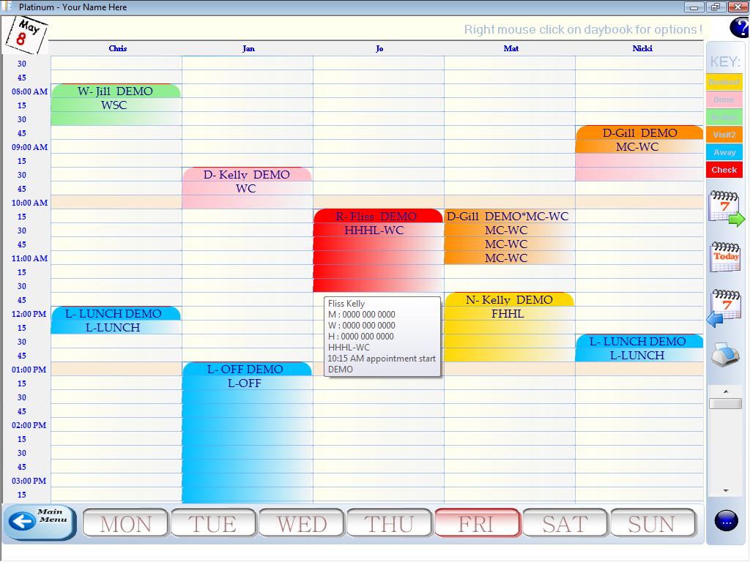
The Electronic Appointment Book
The DayBook is a computerised version of the paper appointment book that has been used in the past. This is where appointments are recorded and organised in Platinum.

To book a new appointment, simply select an empty time under an employee name, search for, or create, the customers profile. Select the service they would like and book them in!

In future, their ‘usual’ can be copied easily and durations of services are all automatically ‘learned’ by the system as you use it. Super fast re-bookings; with no expensive setup needed.


It's easy to organise appointments using the Day Book…

If customers request for their appointment to be moved or if re-organising is needed, appointments can be drag & dropped to a different time or employee. If appointments need moving to a different day, the 'Move this Booking' button is used. Move from day to day by clicking the Monday to Sunday buttons and move week to week using the forward/back week buttons on the side menu.
Monitoring who has paid, arrived or cancelled…
Platinum allows you to change the colour of appointments in the day book to show if customers have arrived or paid. Cancelled bookings are removed from the day book. Group payments are handled easily with an intelligent wizard.

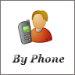
- Green = Paid
- Pink = Arrived
- Yellow = Not Arrived Yet


Cancelled bookings are recorded as:

- By Phone
- By Email
- In Person
- No Show

If a booking is cancelled by a ‘No Show’, there is a record automatically made on that customers profile and the next time they try to book, reception is alerted to the risky customer!

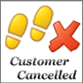

When the customer is ready to pay…

When a customer appointment is finished, the pay process for the appointment is started.

Platinum increases product sales - During the pay process, Platinum reminds you to ask if the customer would like to buy any products. You can also lookup their history of product purchases and suggest that they buy some more.
Platinum increases service sales - by bringing customers back to you on a more frequent basis and building a larger regular customer base. Platinum does this by prompting to ask if the customer would like to pre-book for their next appointment. If so, the next appointment is automatically entered into Platinum.

Keeping a record of appointments…
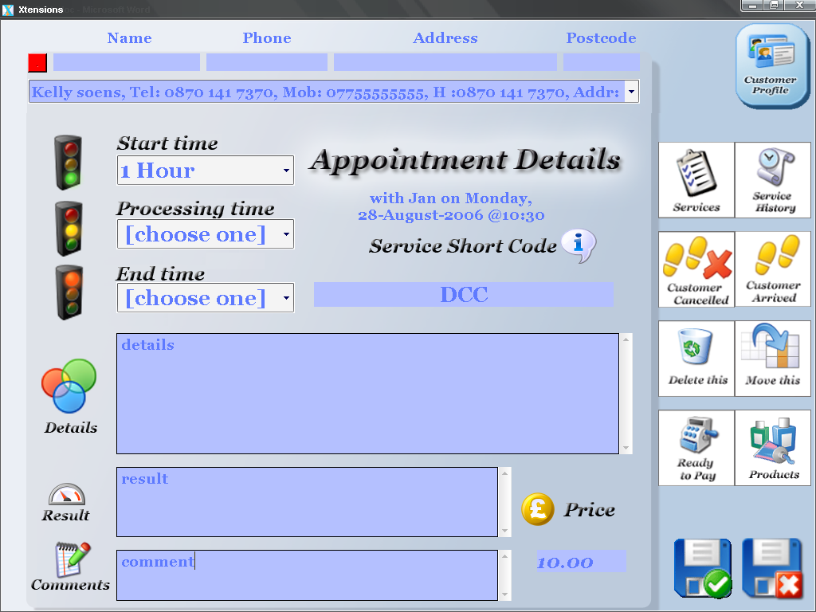
After the customer has left you, the details of the appointment can be entered into Platinum.

These details are entered into the ‘Appointment Details’ page. Information recorded about each appointment a customer makes covers:
- Services and time taken
- Notes of customer specific details
- Result of services
- Price paid + any discounts
- Products bought
- General comments
- Setup regular repeat appointments

Details of previous appointments (Service/Product History) are then recorded for the next time the customer books an appointment.


Previous appointment details are viewable:

At the point the customer is booking an appointment by telephone

When the customer has arrived for an appointment (in ‘Appointment Details’)

As a print-out given to the employee taking the appointment

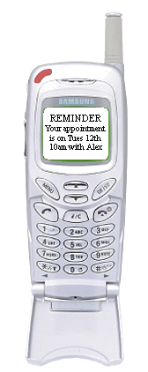

Automatically keep in touch with customers…
One of the most powerful features of Platinum is its ability to automatically send reminders to customers.
Reminders are sent by text message or email and customers can reply saying Yes or No.
This is called two-way and their reply will update the electronic daybook and change appointment colours. You then know who cannot make it without calling them all and wasting your precious time.
There are two types of reminders:
1. Appointment reminders - Email or text message
Appointment reminders are sent out to customers one or more days before their appointment.
This feature:
- Cuts down on no-shows and customer lateness
- No need to spend lots of time phoning to remind customers of their appointment
- Projects a professional image

2. Re-Visit Reminders – Letter, Email or text message.

Re-visit reminders can be automatically sent out to customers if they have not visited you after a certain time, they can also be printed and posted.

To project a professional image, re-visit reminder emails and text messages are personalised to your individual image with your logo etc.

This feature will:

Prompt your customers to come back for their next appointment

Increases appointment numbers

Builds customer loyalty

Special offers can be added to emails

Happy Birthday, Thank You and New Stock Messages:

Optionally send automatic happy birthday offers and after a customer has visited you automatically send them a thank you message on their mobile phone or e-mail. Platinum customer purchase profiling let them know when products are back in stock that they normally buy.

Please note that you will need an Internet connection for sending text messages and emails


Keeping an eye on your business…
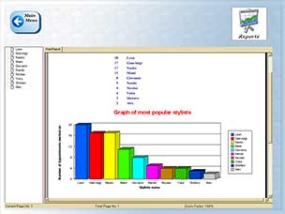

There are a huge amount of reports that cover all parts of your business, from end of day takings/till total, stock that needs re-ordering, products & service sales, employee performance, tax amounts to pay and even customer buying patterns.

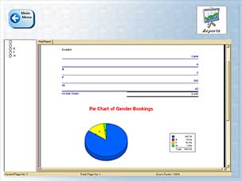
Examples of reports:

Till Total (End of Day Takings Amount)

Stock that needs re-ordering

Commission and salary calculations

Financial income and tax repayments

Product Sales / Service sales

New customer registrations

Non returning customers

Money taken per employee

Products that need re-ordering

Appointments by gender/age/Employee

Customers by postcode

Cancelled bookings

Effective time use of top employees

Commission and salary calculations

Invoicing and Outstanding payments

If any customer details appear on a report they can be used to easily eMessage them with marketing messages via E-Mail and SMS Text Messages. For example, customers who have not visited for a while.

Reports can be viewed over any amount of time from 1 day to the entire life of your business…

Advanced Features

Order Manager

In the office or taking orders on the move via a wireless connection, this allows you to interact with your web credit card processor e.g. WorldPay and creates an order in the system for products purchased. You can even send a customer specific e-mail to head office with special instructions, at the time it is sold, so head office knows straight away and your customers get their products delivered as soon as possible.

Invoicing

Once an order has been taken via Order Manager you can optionally create an invoice with all the correct details for e-mailing or putting in a letter for posting saving huge amounts of administration time.

Order Processor

At each stage of an order you can automatically send e-mails or text messages to customers to inform them of the progress of their order, this greatly reduces order chasing phone calls. When their products are dispatched the system will automatically send an order tracking web link to them.

XAuction

Auction off any product you have on the database with a stylish web auction which keeps customers interested in your website and even gets them buying products they missed out on at auction.

XScreenSaver

You can supply a screen saver on a disk or via download, which allows you to inform your customers of your top 10 new products in stock. The screen saver shows a picture of the product and some details, if the customer likes what they see, with just one click it will take them to the purchase page to buy that product.

XWeb

Each of your customers can be setup with a secure web based account allowing them to alter their own contact data should it change.

Event reminders

Send out Letter, e-mail and Mobile text message reminders of your events to your various customer groups.

Features customised for your business

If you feel something is missing that is vital to your business, you can ask us to include it either as a condition of use or as a feature that will be included in future. There will be a cost involved if very specific to your business.

Platinum Hardware can be supplied by our partner company this means that you cut out the middle man and in some cases can get hardware for half the prices quoted elsewhere!

Computer with Touch Screen

Platinum can be installed on a modern computer running Windows 2K, XP or Vista. We recommend a separate touch sensitive screen allowing you to quickly touch the buttons on the screen rather than use the computer mouse. Touch screens are much quicker and easier to use than a computer mouse but depends completely on your budget.

Intel Pentium 4, 2.4 GHz or better

15” Touch screen (17” Optional)

1Gig Memory (1024 MB RAM) - 80GB hard drive, Mouse, Keyboard (On-Screen also Available)

Windows XP or Windows Vista

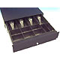
Cash drawer (also comes in white)

Platinum works with a cash drawer. When an appointment is finished and the customer is ready to pay, the payment process automatically pops open the cash drawer to allow access. There are different sizes of cash drawer available and all are lockable with a key.

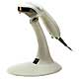
Bar code scanner (also comes in black)

Platinum also works with a bar code scanner. During the payment process, if the customer buys any products they can be scanned into Platinum using their bar codes. The bar code scanner just sits on the reception desk and products can be simply passed underneath to be scanned.
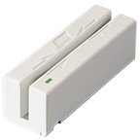

Customer Loyalty Swipe Cards

Platinum keeps track of loyalty points to keep your customers interested and coming back.
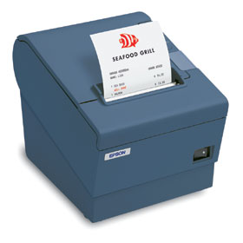

Receipt Printer

Print a professional receipt with your company logo and contact details on it.

Print appointment reminder cards quickly and automatically instead of writing them out.

Print a gift voucher with a two line personal message on for gift cards.

Finger Print Access and “Caller-Id”

Secure your system with finger print access instead of swipe cards or password/pin numbers and surprise your customers by knowing who they are and their full history with “Caller-Id”

Summary of Key Features
- Simply easy to use!
- Record all customer contact details, etc.
- Record details of customers appointment history
- Stock control – automatic and without the stress!
- Stock re-order report to reorder stock quickly
- Print Letters, Email and Text messages* of special offers
- Impressive Text Message reminders to mobile phones
- Impressive Email & Text Marketing with rebook prompting
- Service durations are ‘Learned’ so no expensive setup is needed (Artificial Intelligence)
- Troublesome customer identifier – you get a warning when they are next in
- Levels of security (e.g. staff, receptionist, manager...)
- A huge amount of Reports on customers, employee and business performance
- Keep records of suppliers
- Customers can use the internet to book appointments**
- More appointments, more frequently with quiet day alerts
- Build customer loyalty using customised swipe cards
- Order Manager and Order Processor
- Automatic ‘new stock’ alerts to your customers, based intelligently upon what they usually buy
- Auction off any product in your database on the internet
- Project a professional image with your new system
*Text Messages have a cost **special setup is required at a small cost

Setup and Training
We offer many ‘free’ services across the internet – an initial 1-2-1 demo, we setup your data, a 1 hour free training session and we take a list of products and prices an import them to save you typing.
We offer a free demonstration over your Broadband Internet or Telephone and can also train and set you up over the internet, but please view the Demo DVD in the back of this pack initially.
A free on-site demo depends upon your business location.
We can visit you to setup your system and train your staff, which is at a cost and depending upon location.

Simplicity has been our main goal with Platinum.
It is a system that anyone can use, with no computer skill level needed.

