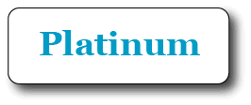

Welcome to the Platinum User Guide

Table of Contents:-

Page 2 Getting Started, Logging in
Page 3 Main Menu—Overview
Page 5 System Set-up—Demo to Live and Personalising Platinum to your business
Page 9 Day Book Diary Navigation
Page 10 Making a booking, creating a customer or searching for an existing customer
Page 11 Looking at customers past appointments, creating new appointment
Page 12 Moving appointments, to a different employee, to another time or to another day
Page 13 Changing the length of an appointment or deleting an appointment
Page 14 Cancelling appointments
Page 15 When customers arrive
Page 16 When an appointment has finished—The Pay Process
Page 20 To Change Service and Product Prices Temporarily for One Sale
Page 21 Symbols and Codes used on the Daybook
Page 22 Quick Product Sale (incl. In-Shop) and Quick Service Sale
Page 24 Booking time off for employees
Page 25 Booking two employees for one appointment
Page 26 Appointment Reminders— E-mail & Text message
Page 27 Sending email marketing messages to customers
Page 28 Viewing reports on end of day takings and business performance-Basic Figures
Page 31 Daily Cashing-Up, End-of-day final till totals, z-out, Discrepancies
Page 33 Trouble Shooting for Cashing Up at End of Day.

Contents

Page 35 Reports - Printing and Exporting of Reports Page 37 Reports for Accounting - Restricting a list of reports for staff use.
Page 38 Time Saving Tips (Crucial Reading!)
Page 45 More advanced topics:
Multi Departments, Multi Level Pricing, Vouchers, Courses, Security
Page 51 Extra Set-Up Options – Easy Set Up Area
Page 54 Department SetUp Instructions
Page 55 Naming the Price Columns for Services/Treatments
Page 56 Setting up SMS Messages within Platinum
Page 59 Emessaging – How to send emails and SMS text messages
Page 60 Marketing Ideas for Emessaging
Page 61 Staff Security Set Up Information
Page 63 Hardware Set Up Help
Page 64 Hardware Trouble Shooting Help
Page 65 Computer Security
Page 66 How Do I proceed? (Purchasing Platinum and/or Hardware)

Don’t forget to read the time saving tips section and for more detailed information and real questions and answers from existing customers, that you can actually search, please click the blue ‘Help Me’ button on the Main Menu.

Starting Platinum

To start Platinum, double click the icon named ‘Start Platinum’ on the desktop.

Sign in

After starting Platinum, the first page shown is the ‘Sign in Page’.

Signing in as Staff/Reception

Staff do not have access to most of the features e.g. Email Marketing and reports but you can give them access. To log in as staff, click the Staff Button on the Sign in Page.

Signing in as Manager – Demo Password = manager

The Manager has full access to all Platinum features and can setup pin numbers and secret words for employees to allow access and to track what employees are doing. This password can be changed. To log in as Manager, click the Manager Button on the Sign in Page.

Getting Started
The Sign-in page
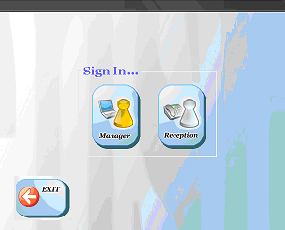
The Platinum icon
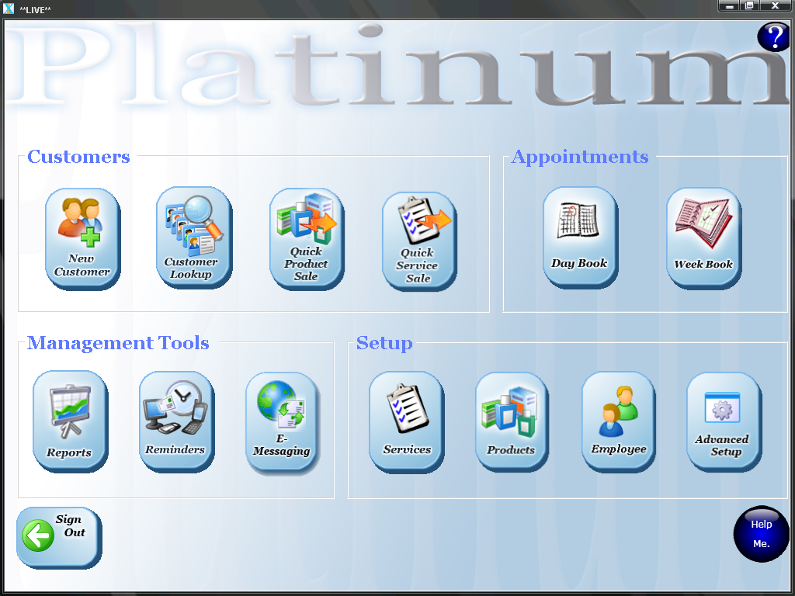

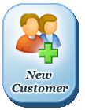



Customers

New Customer – Click this button to add details of a new customer e.g. Name, address, phone number.

Customer Lookup – Click this button to search for and change details of existing customers that are stored in the database. Results are shown in a list view.

Appointments

Day Book Diary – The Day Book is the area where appointments are added to your database.

Week Book – The Week Book is the area where a weekly view of all appointments can be seen.

Reminders (SMS & Email) – Use this area to send appointment reminders to customers via both email & text message.

Main Menu
Overview of features...
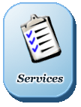



Management Tools and System Set-up

Reports – Here a manager can view information on
business performance. You can report on groups of customers and
contact them, very easily, using eMessaging.

eMessaging – Used to send mobile text messages and email marketing messages to customer groups, very easily.

Services – Allows adding, editing or deleting services that
you provide including multi-prices for employee skill levels. You can
order your top services first on screen so it’s easier to choose them.
** Platinum has Intelligent Learning, once service durations are filled in; the system ‘learns’ them and you never have to set them again **

Products – Allows adding, editing or deleting of products including buy and sell price, stock level and re-order level. Reports
can be run to allow you to easily re-order stock.

Employees – Allows adding, editing or deleting of contact
details, commission%, pay amount and skill level. The pin security
number is used to track their use of the system.

Roster – Is used for booking leave, days when the business is closed etc.

Main Menu
Overview of features...
Platinum Set-up
Part 1 – Demo to ‘LIVE’

When you first install Platinum it is in DEMO MODE – with example information already in the database i.e. employees, services, products and appointments.
We recommend you have a really good play about in demo mode as a very first step.
Do not skip to the next page until you have had a good play - ‘Platinum Set-up Part 2’
Before you can use Platinum properly in your work place, you will need to switch off demo mode to remove the example information. You can then start entering your own details into Platinum. Talk to us first if your business uses an appointment diary and you need less than 15 minute appointments slots.

How to switch off demo mode – **DO NOT DO THIS IF YOU HAVE ENTERED YOUR OWN LIVE DATA AND YOU NEED IT SAVING ***

Use different option below

From the Main Menu click on the ‘Advanced Setup’ button in the ‘Set-up’ area.

Now click the ‘Switch off demo mode’ button.



Click ok to any messages that pop up. (There will be a number of warnings, if you have not added any of your own data just click OK)

Restarting Platinum and logging in

Now, go back to main menu, logout and exit Platinum so the program closes.

Start Platinum again and login as manager (password is just the word manager).

You are now ready to start entering your own details.

Note:- If you want to go LIVE but have added your own data already, you can just switch off the pop up help windows by doing the following:-

You must be signed in as Manager - From Main Sign In screen of Platinum, right click your mouse and select:-
Only if Asked…..Only If Asked…..Out Of Demo Mode (keep my data)
You will need to restart Platinum
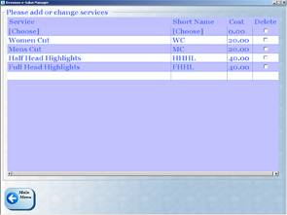
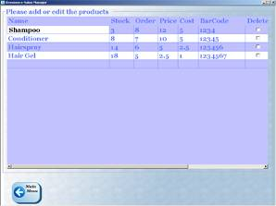

To personalise Platinum, there are four main areas that need setting up: Services, Products, Employee and Roster/Opening Hours.

Setting up services – Daybook is 15 min. slots as standard
(If you find you need 5 min slots please contact us for set up)

From the Main Menu click on the ‘Services’ Here you list all the services that you provide.

Under the ‘Service’ heading type a long name for the service.
The Short Name can be left blank and is automatically created using the first letters of service name, but you can change these.
Under ‘Price’ type the price you charge the customer. There are a number of columns you can use if you have different pricing levels for different staff members.
Repeat steps 1 to 3 for all the services you provide.
When finished, Click ‘Main Menu’ to save.

Tip: If you scroll to the right and find the
column called “The Order” you can order your
top services to show first, 1 being the top.

Setting up Products

From the Main Menu click on the ‘Products’ button in the ‘System Set-up’ area.
Here you list all the products that you sell.

Under the ‘Name’ heading type a long name for the product.
Under ‘Stock’ type the number you currently hold in stock
Under ‘Order’ type the number that stock should fall to before you need to reorder e.g. if you reorder when only 3 items are left in stock, type 3.
Under ‘Sell Price’ type the price that is charged to the customer. Enter ‘Buy Price’ from your supplier if you want profit to be calculated.
If you use a barcode scanner, under ‘Barcode’ you can scan (or type) the barcode number of the product.
Repeat steps 1 to 6 for all products sold.
When finished, Click ‘Main Menu’ to save.
Platinum Set-up Part 2
Services Setup
Products Setup
NOTE: To delete a service, scroll to far right, double left mouse click ‘Delete’ next to the service and then click ‘Main Menu’ to save.
NOTE: To delete a Product, double left mouse click ‘Delete’ next to the product and then click ‘Main Menu’ to save.
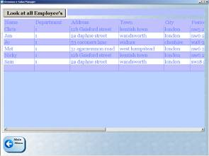
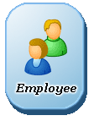
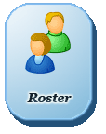

Setting up employees

From the Main Menu click on the ‘Employees’ button in the ‘System Set-up’ area.
Here you enter the names of all employees.

Under the ‘Name’ heading type the name of the employee(to add more to the list type in the bottom empty box).
Only use ‘Department1’, talk to us for more.
Fill in as many of the other columns as needed. These are just for your own records and are not needed e.g. Address, Phone etc.
Repeat steps 1 to 3 for all your employees.
When finished, Click ‘Main Menu’ to save.

To ‘Order’ your employees in the daybook. Use the column ‘order’. Order No. 1 is far left in the daybook. No. 2 is to the right of this etc.

If you have more than one pricing level, make sure you direct your staff member to the correct price level. Click in the ‘level’ column and select correct price level (this must be linked with the price levels you have added in the Services screen

Setting up the Roster

From the ’Advanced Setup’ Menu click on the ‘Roster’ button, this is for keeping track of which day’s employees are not working.

Instructions
Select the employee who will have the day off
Double click the dates they will be taking off or select multiple days by click and dragging multiple dates.
Repeat steps 1 and 2 for all employees until all timetables have been entered.
Click ‘OK’ to Return to the Main Menu
Notice that the Day Book will not show the employee name on the days you have marked as off.

Platinum Set-up Part 3
Employee Set-up

NOTE: To delete an employee, double click ‘Delete’ to the right of their name and then click ‘Main Menu’ to save.
NOTE: The roster is only for marking FULL DAYS off, not half days.
To mark half days or mid day breaks see page 22 (Booking time off)
NOTE: If an employee is marked as having the day off, they will not appear in the Day Book on that day.
On Newer Versions (2009Q3)

Days Off Each Week - employee can be set to NEVER be in on certain days to make rostering a lot easier and faster.
In Roster.. (…) blue button….I want to roster staff who are off same day each week….
Select the employee name and tick the days that they are IN and working (untick if not in and they will not appear on the daybook for those days.).
Setting daily start and end times

You should alter start and end times for each day to coincide with different opening hours.
Go to More Set Up from Main Menu, go into Roster, using the (…) button in the top left hand corner, select the option ‘I want to change the opening hours by day’. Select your daybook option of 15 or 5 minutes and a scheduler screen will appear.
Choose the day and the opening hours (its 24 hrs so, for example, 5pm is the number 17)
Set times once for each day (if no department set up, always use Department 1 as default)

Check the daybook is showing required times.

Set Up of Receipt Printer Text

Once the receipt printer is installed, restart Platinum, it now should sense the new receipt printer and pop up the receipt text for customisation.

You will add the business name and any contact details;

**CRUCIAL NOTE**
Do not remove or replace any data inside the square brackets.
Do not use tabs, just spaces in the files

If the receipt text does not appear or you wish to change any details at any time, receipt text, appointment card text and voucher text can all be found in:-

Platinum Main Sign in Screen (you must be signed in as manager)
Right mouse click in empty space
Only when asked
Xtra’s
Customer Experience
Right mouse click…edit the files where necessary.
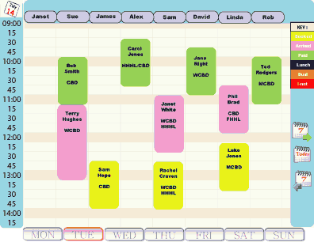
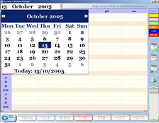
The Day Book
What is the Day Book?

If you are happy with your paper diary daybook, that’s great, continue using it and use the Quick Service Sale from the main menu. You can decide to use the daybook at a later date.
The Day Book is like the paper appointment book that is used to keep track of appointments.
It is here that appointments can be booked and managed.
The Day Book shows one full day of appointments and you can have a daybook per department.

Navigating around the Day Book

Moving from day to day – When the Day Book opens, today’s appointment schedule is shown. Moving from day to day in the Day Book is done by using the Monday to Sunday buttons along the bottom of the screen.

Moving from week to week—To move to a different week, use the buttons on the right of the screen marked with the number 7 and arrows that indicate forwards and back. Once navigated to a different week, use the buttons at the bottom of the screen to go from day to day in that week.

Moving back to today—To move back to today’s view, click the ‘Today’ button on the right.

Using the easy calendar—Click the date at the top left to reveal a large calendar (see below). Scroll through the calendar until you reach the day you wish to view and click. The day book will move to that day.
The Day Book
NOTE: The date of the day you are looking at can be found in the top left corner. You should always check this before making an appointment.
Easy Calendar
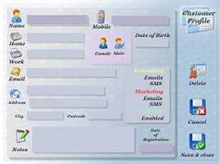
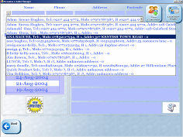
Booking an appointment
To book a new appointment into the database, find an employee who will take the appointment, click an empty cell under their name and start time.

You will now see the ‘Customer Look up’ screen.

You need to either:
Create a new customer profile
Or
Find the name of an existing customer

Creating a new customer
If the customer does not yet exist in the database you will need
to create a new customer profile for them.
Click the ‘New Customer’ Button (Top Right).
Enter the customers’ details.
Note: It is important to enter at least their name, telephone number (preferably mobile) and gender.

Searching for an existing customer
If the customer is an existing customer that is already in the database you will need to search for their profile.
Using the search fields at the top of the screen, enter the customers name, telephone number, address or postcode

Note: You can search using two or more categories e.g. name and postcode.
Entering an appointment
Customer Lookup
Add a New Customer
Search for an Existing Customer
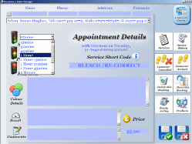
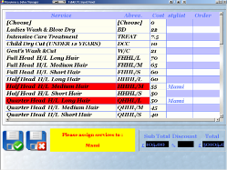
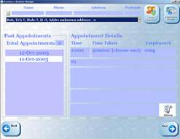
Select duration of appointment
Add a New Appointment
Viewing a customer’s past appointment details
After finding and selecting the customer, you can view details of past appointments, services and products. Use the ‘History’ list to switch between past appointments. ‘Details’ section gives the specifics. This is useful if you are assisting a customer in deciding which services or products they should choose again, by referring back to previous appointments.

Make a new appointment

To book a new appointment for a customer, click the ‘Next’ button.
The service selection screen is now shown so that you can select the services for the appointment. Once selected it will turn red. If you know the services short code simply type it in to select that service very quickly. It will be added to the total. To remove a service simply click its name.
After selecting services, always check the total, then click OK.

The appointment details page is now shown. You need to select the duration for the appointment. There are three boxes for time selection—‘Start’ and an optional ‘Processing’ and ‘End’.
Fill these in as needed.

Important: Once these service durations are filled in; the system ‘learns’ them and you never have to set them again.

You can make notes for this appointment in the various boxes.
When you are finished, click the Green Tick to return to DayBook.
You will now see the appointment that you have just booked!

View Customer history,
book a new appointment
Appointment History for selected Customer

Moving appointments

To move an appointment to a different employee or to a different time slot during the same day

1. Click and hold an appointment while dragging it to its new employee or start time.
2. Release the mouse button when you are happy that the appointment is relocated to the correct place.

NOTE: If you are moving the appointment to a time either later or earlier on the same day and the start time is not visible on screen (off screen), temporarily drag and drop the appointment to an empty slot nearer the preferred start time and use the scroll bar on the right either up or down so as to reveal the preferred start time.
Drag and drop the appointment to this time when it is visible.

To move an appointment to a different day

1. Click the appointment.
2. Click the ‘Move Appointment’ button.
You are sent back to the Day Book.
3. Go to the day you want to place the booking.
4. Choose a suitable employee and click the start time for the appointment.
5. The appointment is moved to this new location.

Tip1: When finished always return to ‘Today’ to avoid confusion regarding which day the DayBook is focused on.

Tip2: To copy a regular appointment
or even a regular ‘leave type’ eg. Lunch.

Simply open it from the daybook and hover over the picture button called ‘Move This’ for easy instructions.

Moving multiple appointments on the same day for the same customer

Platinum will not automatically move the 2nd/3rd appointments to the same time on the new day, as it can lead to double bookings/hidden appointments under other ones. Once the first appointment is moved a list is shown of their OTHER appointments "that day" you can then move them manually.
When deleting an appointment which is part of ‘multiple’ appointments for that day, it will warn you to investigate them/ask the customer if they wish to cancel them also.

Moving and copying Appointments
Moving an appointment by using drag and drop
Move to a different day
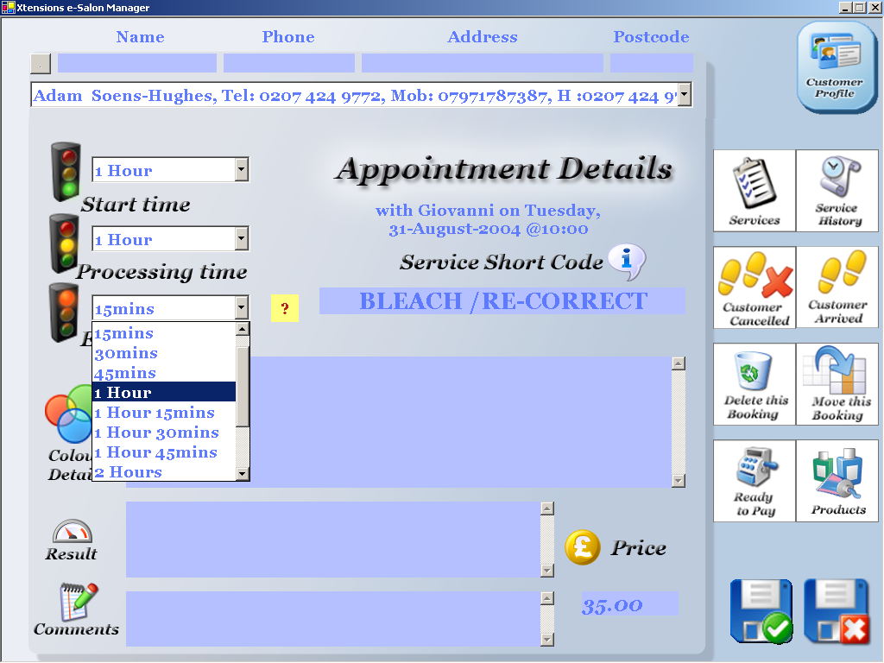

Appointment Details
Appointment Details

Increasing or decreasing appointment duration
1. From the daybook, click the appointment to reveal
its details page.
2. Alter the start, processing or end time.
3. Click OK to return to the Day Book.
Notice that the appointment has been adjusted accordingly.

NOTE: If you re-open and change an appointments duration,
this new duration will not be used in future for new
appointments. The system only ‘learns’ the
durations from the last new appointment created with
this specific employee.

Deleting an appointment
1. Single click the appointment in the Day Book to reveal its details page.
2. Click the ‘Delete’ Button.
3. You will be prompted, asking whether you are sure you want to delete this appointment.
4. Click ‘Ok’ if you want to proceed.

Changing appointment duration
or deleting an appointment
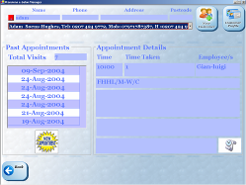




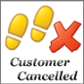
Red Mark against Customer Name
Select how the customer cancelled the appointment
NOTE: If a customer does not show up for an appointment, Platinum remembers.

Next time they try to book an appointment, after you search for their name, the top of the screen will turn RED indicating that they have a red mark next to their name. Click on ‘Customer Profile’ and look at ‘notes’ to view the reason why they have a red mark next to their name.

Tip: When a customer is set to no-show you can optionally send them a mobile text message and e-mail to ask them to contact you to re-schedule. This means they are more likely to stay a customer and not be too embarrassed to ever return.
Cancelling an appointment

If a customer cancels or does not show up for their appointment, you can mark the appointment as Cancelled or no-show.

The system can then allow you to send them a ‘please rebook’ email or SMS text message – as an ‘ice breaker’ to make sure they do actually come back in future.

No shows are logged for future reference.
To cancel an appointment:

1. Single click the appointment in the Day Book to reveal its details page.

2. Click the ‘Customer has cancelled’ button.

3. Select the method that the customer used to cancel the appointment
– ‘By Phone’, ‘By Email’, ‘In person’ or ‘No Show’ –

4. You are now taken back to the Day Book, and you will see that the appointment has been removed.

When a Customer arrives
Appointment Colour Key
NOTE: Appointments change to a different colour depending on their status.

For example, ‘Booked’ appointments are gold, ‘Arrived’ appointments are pink, and ‘Paid’ appointments are green. If you use this it means you can easily see who has not made their appointment as it will still be gold. You can then eMessage that person with a mobile text message
and email to request that they get back in contact
to avoid any embarrassment. Which could mean that they never deal with you again.

There is a key on the right side of the Day Book indicating what each colour means.

This is to remind you of each colour meaning.
Marking a customer as ‘Arrived’

When a customer arrives, you need to mark the appointment as ‘Arrived’.
To mark the customer as ‘Arrived’: 1. Single click the appointment in the Day Book to reveal its details page.

2. Click the ‘Customer has Arrived’ button.

3. You are now taken back to the Day Book, and you will see that the appointment colour has changed to pink.

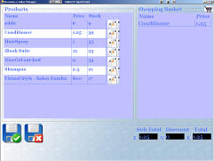
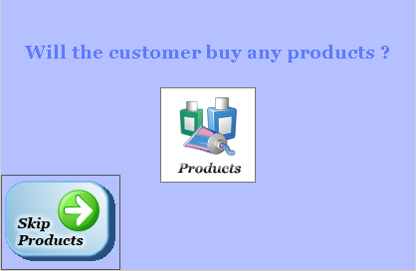

When an appointment has finished
When an appointment has finished, the customer needs to pay so you need to start the ‘Pay Process’.

.
To mark the appointment as finished:

1. Single click the appointment in the Day Book to
reveal its details page.
2. Click the ‘Pay’ button. You are now taken through
the ‘Pay Process’.
NOTE: Platinum prompts staff to ask the customer if they would like to buy any products or courses. Click ‘Products’ if they wish to buy products, these words can be set to whatever you like to remind staff to up-sell in ‘your own words’.
Hold down the SHIFT key on the computer keyboard and click to see their purchase history.
If the customer wishes to buy products, the products selection screen is shown.

To select products that the customer would like to buy, search through the list of products and click the product name. The product will now appear in the shopping basket. If you need to add a discount, you can do this here by inputting a percentage discount or by just changing the price. (shift ^ click on price)

Using the barcode scanner:

Alternatively you can use a barcode scanner to scan the products into the shopping basket. To do this, find the barcode for the product and press the scanner button. The product will automatically be added to the shopping basket. Repeat the process with the next product if required until all products are added to the shopping basket.

Removing products from the list: to remove products from the shopping basket, click the product name in the shopping basket. When you are finished click the green tick save button to continue...

Tip: You can type part of the name of a product to reduce the list down, type a few characters, wait half a second and press the enter key. Press ESC (top left) to return the full list.

The ‘Pay Process’ ...Up-Sell products to customers
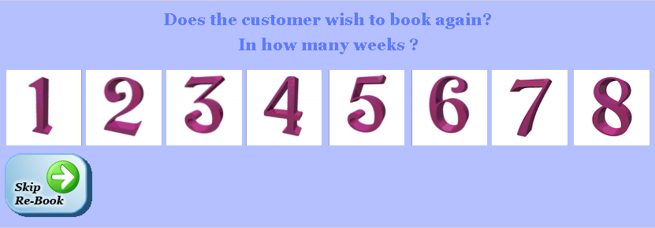
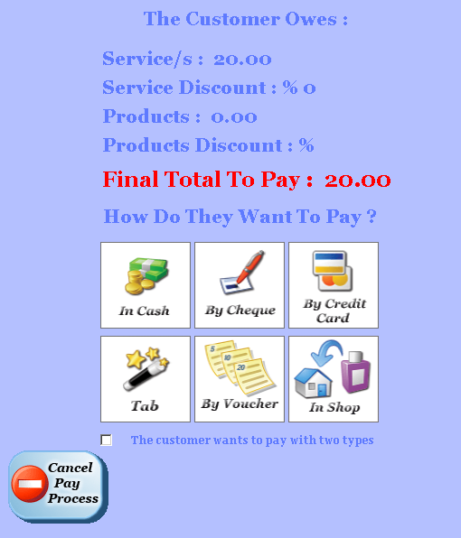

When an appointment has finished -Part 2
The ‘Pay Process’ continued...request a rebook
Ask the customer if they would like to book again for their next appointment.
If the customer would like to pre-book their next appointment, click the number of weeks away they would like to book their next appointment.

NOTE: If the customer does not want to rebook their next appointment, just click ‘Skip’.
The ‘Payment Method’ screen is now shown. Here you will see a breakdown of the total bill for the appointment. Total price for services and products is shown along with any discounts.

Click the method of payment that the customer has chosen (Cash, Cheque, Credit Card, Voucher or Tab). Once chosen an optional cash drawer will open.
You are now taken back to the Day Book to place the new re-booking.

NOTE: Click ‘Cancel’ if you would like to exit the pay sequence without saving any changes. If you do this, you will return to the Day Book where you can start the payment process again from the beginning for this appointment.

To change any values without cancelling the pay process, simply click a value in the boxes
e.g. Service discount.
This will then allow you to edit it.

For Mixed payments, Cash and Voucher for example, tick the box at the bottom, or Hold down the ‘Magic’ SHIFT key on the computer keyboard and click both types.
If the number of weeks ahead is greater than 8, just click 8 and then use the calendar in the top left of daybook to move to appropriate date. Platinum will still have the appointment details to place on the daybook when you click the requested time/date slot.

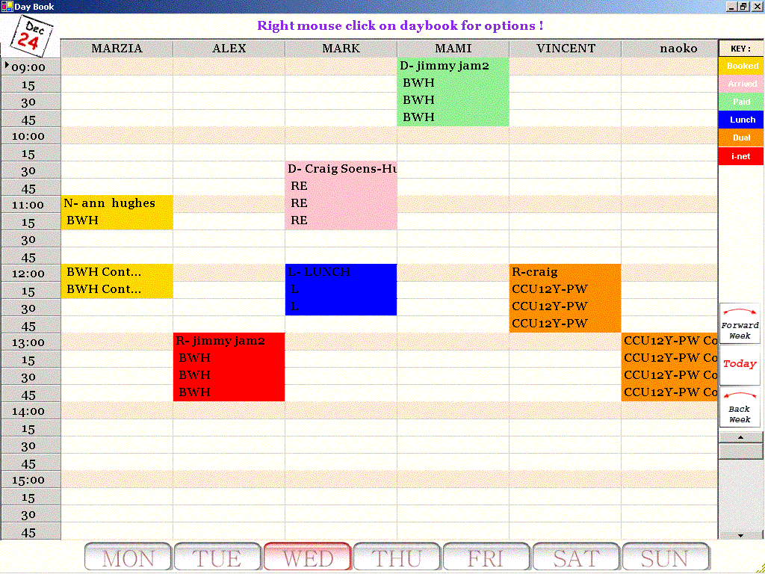
When an appointment has finished -Part 3
The ‘Pay Process’ continued...make the rebooking
If the customer requested a new booking, the Day Book is taken into the future by the number of weeks that were requested e.g. 4 weeks.
Simply click the correct time under the chosen employee to drop the new booking into place. The booking that is made is an exact copy of the appointment that the customer just had.
NOTE: The booking is coloured red; this indicates that the booking needs to be ‘approved’ i.e. the service details need checking to make sure that the customer requires the ‘same as last time’.
To ‘Approve’ the booking or change the services that the customer has at the time of the new booking:
Click the appointment to reveal its details.
Click the ‘Services’ button.
Change the services selected as needed
Click save to services.
Click save to appointment details.

You are now taken back to the Day Book where you can see that the new booking has changed to yellow i.e. the normal colour of a booking.

NOTE: Click ‘Cancel’ if you would like to exit the pay sequence without saving any changes. If you do this, you will return to the Day Book where you can start the payment process again from the beginning for this appointment.

To Alter Service and Product Prices Temporarily for One Sale

You may want to amend a price for a service or product sale just for one appointment/sale. This can be done without amending the master list/prices.

Services:-

Open the appointment and on the details screen click the Services icon top right hand side of screen 

Click on the price that is alongside the service selected (the selected service/s will be in red) type the new price/s

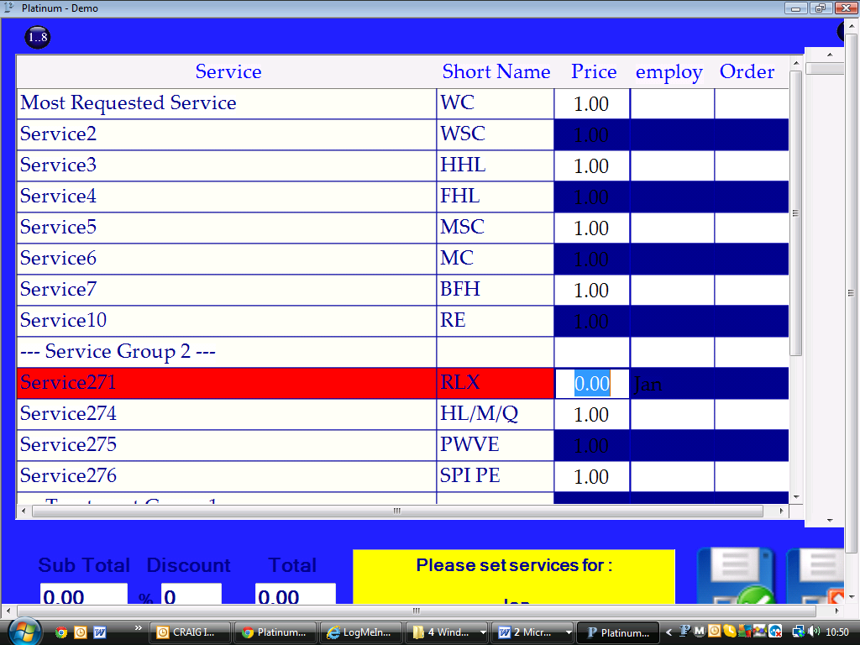

Products:-

When the item is in the shopping basket hold the Shift button down and click on the price, Platinum will ask for the new price to be entered.

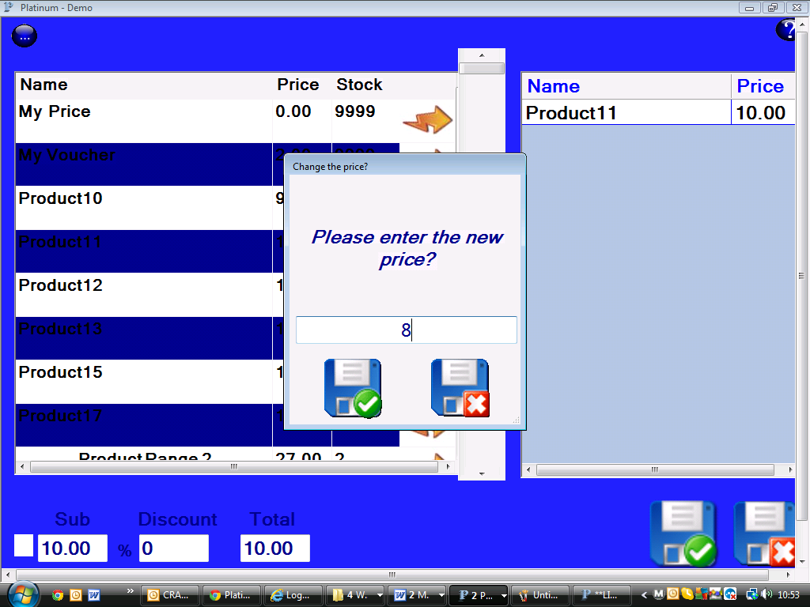

NB. These prices are only changed for this one Sale/Appointment

Symbols and Colour Codes Found on the daybook

"VisitType" codes:
W - Walk-in
N - New Customer
R - Requested this employee
D - Don't care which employee I am with
C - customer referral
Daybook Extra Prefix Symbols:
L = Away or Leave types (Off, Lunch, Training, etc)
@ - Membership
# - Appointment confirmed
_ - when an appointment is made without selecting a visit type
(as that selection screen can be optionally disabled)
! - Dual appointment second employee on the appointment
(may only be seen when combining symbols)
NOTE:
A room number or the first two letters of a room name can be added to the appointment prefix via the xtras... menu from right click on daybook.
Appointment coloured "Status" codes:
- = gold/booked (hyphen)
* = pink/arrived
_ = green/paid for (underscore)

Quick Product Sale (incl. In-Shop) & Quick Service Sale
What is quick product sale?

Quick product sale is used when a customers visits to buy a product without having an appointment.

It is also used for keeping track of products used by employees ‘in shop’.

How to do a quick product sale

Go to the main menu and click the ‘Quick Product Sale’ button.
To select products that the customer would like to buy, search through the list of products and click the product name. The product will now appear in the shopping basket. If you need to add a discount, you can do this here by inputting a percentage discount or by just changing the price. See below.

Using the barcode scanner:

Alternatively you can use a barcode scanner to scan the products into the shopping basket. To do this, find the barcode for the product and press the scanner button. The product will automatically be added to the shopping basket. Repeat the process with the next product if required until all products are added to the shopping basket.

Click the Green tick to save.
Finally, select the payment method – cash, cheque, etc...

NOTE: Platinum can be setup so that you can record which customers buy products through quick product sale, this is good for marketing campaigns.
Easy Set Up……Point Of Sale…….Appointments/sales processes……..Quick product sale.

Quantity

If you hold down the SHIFT key on the computer keyboard and click the product
on the left hand side you will be asked how many to add to the shopping basket
on the right hand side.

% Discounts and price changes

You can give a discount at the bottom of the screen for the whole amount. For just one, hold down the SHIFT key on the computer keyboard and click the price of any Product that is already in the shopping basket on the right. You will be asked for the new price.

Removing products from the list: to remove products from the shopping basket, click the product name in the shopping basket. When you are finished click the green tick save button to continue...

Tip: You can type part of the name of a product to reduce the list down, type a few characters, wait half a second and press the enter key.

Press ESC (top left) to return the full list

How to tell the system a product is being used ‘in shop’
You may want to keep control of how many products are used during an appointment and/or used by staff. Use the same instructions as above but select ‘In Shop’ as the payment method. You will now see a screen that allows you to select which employee is using the product.

This can optionally be pass worded to stop abuse.

NOTE: View the report called ‘Product Use By Employees(In Shop)’
to monitor in-shop product use. (Double click to drill down for detail)

What is Quick Service Sale?

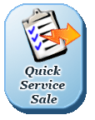
Quick service sale is used when a customers visits to have a service without having an appointment. If you do not use the electronic daybook, quick service sale is a great way to quickly record your financial transactions.

You can choose an employee who is to perform the appointment for commission
tracking and to choose the correct price for that persons skill level.
At the end of the day you can look at the daybook and see all of your sales
visually. Allowing ‘who and when’ analysis to be done.

Tip1: You can click any service price and change it to give a discount, press enter
on the computer keyboard when finished and you will see the new total calculate.
Tip2: If you are familiar with your service short codes, when you see the list of
Services you can type the full short code in and press enter on the computer
keyboard to select it, without scrolling, making it super fast to use.
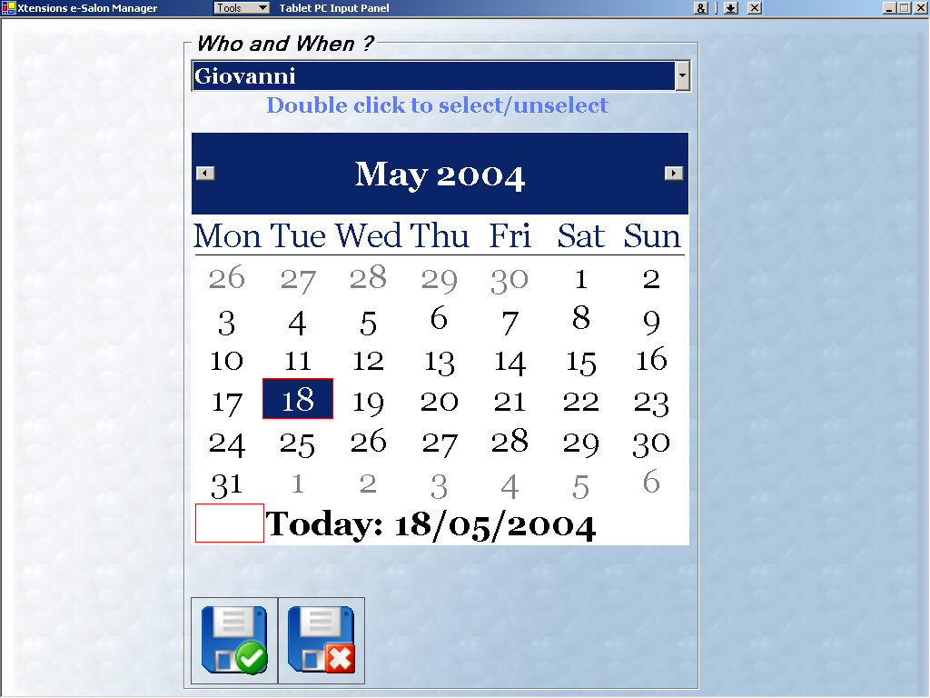
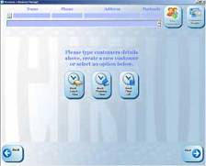

Lunch is marked as a blue appointment

Booking time for leave (breaks,training,days off rostering)
Booking ‘leave’ time
To mark time for lunch for each employee simply book another appointment and click one of the big buttons; LUNCH, TRAINING or TIME OFF.

Instructions
Click the start time under the employee that you would like to book lunch for
Click one of the big buttons; ‘LUNCH’, TRAINING’ or ‘TIME OFF’, these are known as ‘Leave Types’.
Select the length of the break from the ‘Start Time’ drop down list e.g. 45mins, 1hr etc.
Click ‘OK’ to Return to the Day Book, Notice that these ‘Leave Types’ are coloured in blue.

NOTE: You can drag & drop appointments, change ‘Time needed’ and ‘Delete’, the ‘Leave’ types can be drag dropped, the same as any other appointment.
Booking days off

To mark time off for each employee, click Roster on the Advanced Menu.
Instructions
Select the employee who will have the day off.
Double click the dates they will be taking off or to select multiple days, click and dragging multiple dates and click the ‘select all these’ button.
SEE PAGE 7 FOR LATEST INFO IN ROSTERING

Click ‘OK’ to Return to the Main Menu
Notice that the Day Book will now not show their name on the days you have set them as off.
Nice and tidy and no mistakes!

TO BOOK OUT HALF/PART DAYS:-
You must do this via the day book with the Blue OFF options. As above (leave time)
Select from the START time and ‘block out’ the half /part day. From the leave type screen, you are able to add notes at the bottom of the screen to clarify the time off.

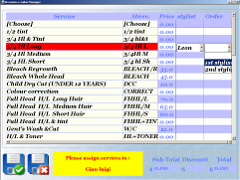
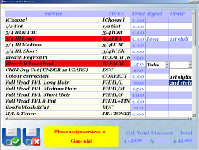
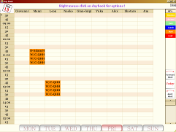

Booking a two employee appointment…
(A ‘Dual’ Booking)
Creating a booking for a two employee appointment

Create a new appointment by clicking the start time under the first Employees name
Search for the customer or create a new one.
Select the services that the first employee will perform by choosing them from the drop down list next to the service name. Also select ‘1st Employee’ from the ‘Order’ drop down list next to each service.
Repeat the process for the services that the second employee will undertake but select the second employee name in the ‘Employee’ column also select ‘2nd Employee’ in the ‘Orders’ Column next to each service.
Click ‘OK’ then select the start, processing and end times for this appointment. Click ‘OK’ to return to the Day Book.

To change one or both of the employees that are working on this type of booking

View the daybook and ensure the employee is free
Click the appointment in the Day Book
Click ‘Services’
Choose either the 1st or 2nd employee and change their name to the new employee you want to move it to.
Click ‘OK’ to return to ‘Appointment Details’
Click ‘OK’ to return to the ‘Day Book’

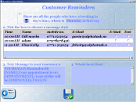

Reminding Customers about their appointments
Reminding Customers about their Appointments

You can remind customers about appointments by text message to their mobile phone or by email to their Inbox.

On the Main Menu, click the ‘Reminders’ button.
When you are in the reminders area, select how many days ahead of their appointment you would like to search for customers.
Search through the list of customers selecting either ‘Send Email’ or ‘Send Text’ (you can select both if you prefer, right mouse on them to select all).
Click ‘OK’, to send your reminders.
Close this window to return to the Main Menu.

NOTE: If there is a problem sending reminders to any customers, search through the list in the ‘4. What was sent’ window to identify why the problem occurred.

Examples of problems are:

You attempted to send an Email reminder to a customer with an incorrect email address.

You attempted to send a text message to a customer with a mobile phone number that is wrong.

**PLEASE NOTE THAT YOU WILL NEED TO CONTACT US TO SETUP THE TEXT MESSAGE REMINDERS FEATURE**

This feature can also be setup to automatically remind your customers, without you having to think about it.

There is a charge per text message but setup and e-mail is free.

TIP: You are able to see what the last text message was that was sent out to a specific customer, from their customer profile menu. This will help for diagnostics if any customer said they didn't get reminder or it arrived too late etc

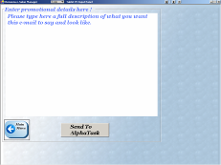
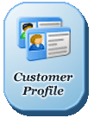

Sending Marketing messages to Customers…Easily…
eMessaging
To easily send an email or mobile text message to all your customers:

1. Click ‘eMessaging’ on the Main Menu.

2. Type your subject, message and SMS text message in the white boxes. (click the … button to save them for later use)

3. Click ‘Next’.

4. You can change the text message in the box, the word [NAME] will be Replaced with the customers name for personalisation. You can see a countdown of remaining letters at the bottom.

5. Choose the customers to send to by ticking the boxes next
to their names. Click right mouse to tick them all.

6. Click send to send the email or Text Messages to the
selected customers, you will see a count down at the
bottom as it sends.

Note: Creating graphical emails requires specialised computer knowledge and can be quite tricky and time consuming to get right. (we can provide you with our preferred suppliers for this)

Tip1: If you choose a customer based report you will see a button that says ‘eMessage Them’ if you click that, you can target JUST the customers who are covered by this report. This allows you to do very powerful and targeted marketing to specific groups of customers with special offers, etc.

With this you have the power to turn your quiet day into your busy day.

Tip2: If you want to contact a customer directly and you have their mobile phone number and email in the system.
You can click the little ‘e’ to the right of their mobile number.
You can find this on the customer profile page. This allows you to JUST contact that one person with an email and/or mobile text message.
Reports
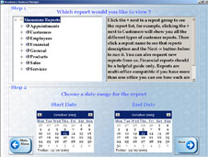
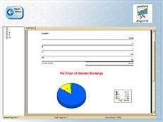
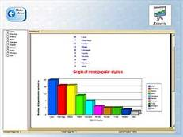
Reports
When the Owner or Manager wants to view how the business is performing, they can go to the reports section, this is a restricted area and a password can be set.
To go to the ‘Reports’ section, click ‘Reports’ from the Main Menu.
You will now need to choose the report that you want to see. Next you will select a start date and end date for the report.

When selecting reports, for information about what the report will show, read the description in the window on the right.

You are able to double click reports to get further detail; hover over a field on the report and you will see what looks like a magnifying glass, double click and it will drill down and show all detail.
An example would be:
Products….Product Use By Employee InShop. By double clicking for detail, it will show a breakdown of all individual products that have been put through to use in the business.

Some reports are viewed ‘per page’ (eg. Employee per page) always check the arrows at the top of the report, if more than one page to the report, the arrows <- -> will take you through the pages.

Example reports

End of day report: If you open the reports screen and go to General or Most Used Reports…End of day.
You will see a report that allows you to double check you’re till total with what the system says should be in there. If you use vouchers you should use the report under Financial…Till Total (Voucher Aware) instead.

Product and Service commission: This report shows how much to pay employees who receive commission for products and services. For example, if an employee receives 20% commission on their services, this will be calculated and shown here, with a total, for any length of time required.

Total Bookings (Men/Women): This report shows the total number of bookings made and highlights which percentage is by men and which percentage is by women.

Bookings by Employee: This report shows the total number of appointments taken by each employee. This report shows a break down of the work done by each employee for a given day. It includes the total price for each appointment and the total money made by each employee for the day. NOTE: This report is not normally used with a period of time like other reports, instead just select the ‘start day’ as the day for the report.

Least Recent Customers: This report shows the customers that have visited the least frequently during the selected time period.

Product Sales by Employee: This report shows the number of products sold per employee (following appointments taken by the employee). It can be useful in analysing which employee is best at selling products to the customers and which need training in this area.

Best Selling Product: This report shows the product that was sold the most during the selected time.

VERY IMPORTANT NOTE:

If the expected amounts for product/service sales, do not match the actual total taken for the day.

Did you take a payment earlier in the week for the appointment?

If you did this will obviously effect the total you take on the day and expected will not match the till.
See troubleshooting at end of guide.

Cancelled Bookings: This report shows the number of cancelled bookings for the selected period and indicates which percentage of these cancellations have been ‘By Phone’, ‘By Email’, ‘In Person’ or ‘No Show’ for internal discussions.

New Registrations: This report shows the number of new customer registrations for the selected time period.

By Postcode: This report shows the number of appointments booked during the selected period by customers from a particular postcode group.

There are more than 150 reports within Platinum, a comprehensive list of all reports and their descriptions can be found here:-

http://www.xpectworld.net/AdviceTeam/reports/reports.html

Batch Reports can be emailed To You
A PDF of all batched reports; you choose some daily reports and they are emailed to you, e.g., end of day, sales, refunds(any reports you choose) can all be emailed to you in one PDF document for review or sending to your accountants.

Service History Report

The service history report is available from customer profile, history and appointment details screens via gel-button (...)

Service History shows previous payments made.
Service history from the right mouse on the daybook (while mouse is over their appointment) has total due plus any discounts given, this enables back reference to what was charged last time.

What’s Been Happening Report

This report allows you to see everything that has happened on the system for any length of time.
To be able to see which employee did what, you must enable pin codes for each employee.

Tax

You should use the ‘tax repayment’ report for general use. The two separate reports are more complex and specialised.

Price Lists

To get a report showing your prices lists for Services and Products;
Go to Main Menu, right click your mouse…..Price Lists…Services and Products
This will give you a PDF report that can be printed or emailed.

How to Find Some Basic Figures…

How Do I Cash Up?

See Page 31 of this User Guide For details.

How Do I see what Sales I have done for the day?

Go To reports…….Sales Services/Treatments or Sales products.

Both sections have summary or detail reports and can be selected for any timescale you choose.

How do I see What Sundries (petty cash) has been used?

Go to Reports…..General or Most Used Reports…….Cash In and Out (Non customer/Sundries)

This report can be used for any time scale and give you the amounts plus descriptions.

How Do I see what Products have been used within the Business?

Go to Reports…….Products…….Product use by Employee (In Shop)

This report will give a value and by double clicking in any field it will give you a detailed breakdown.

How Do I see what Tax is payable on my Sales?

Go to Reports……..Financial…….Tax Repayment Totals By Date

NB. Tax rates must be set up in Easy Set Up…….E-Business……Financial……Tax

How Do I see what My Staff have Been Doing During The Day?

Go to Reports……..General or Most used Reports…….What’s Been Happening

This report will show all activity within Platinum for any time period. To record individual staff activity, pin codes must be activated for each employee.

Daily Cashing Up

Unlike many other systems and certainly the old style tills, Platinum does not require you to click on any ‘cashing up’ buttons or ‘special keys’ to get x, y and z totals.

As long as all appointments are green in the daybook (paid) their totals will appear on a report which allows you to double check your till total with what the system says should be in there.
If you click on the Reports icon from the Main Menu screen, you will see the list of reports.

For end of day cashing up you need to select:-

General or Most Used Reports……….End of Day Till Totals by Department (if your business is using more than one department) OR
General or Most Used Reports…….…End of Day Till Totals by Office

OR If you use vouchers you should use the report:-
Financial………Till Totals by Department (Voucher Aware)
Or Most Used Reports…… Till Totals by Department (Voucher Aware)

Or to keep staff from taking any unexpected extras
Financial………Till Totals (Expected values first)

The start and end dates will be for the day you are cashing up, although can be used for any duration.

You will be asked to enter float amount, you can enter the amount you use for your float but we recommend entering zero (0) as it is less confusing. On each of the reports you will see a breakdown of amounts taken on credit card, cheque and cash (and Voucher if using them)

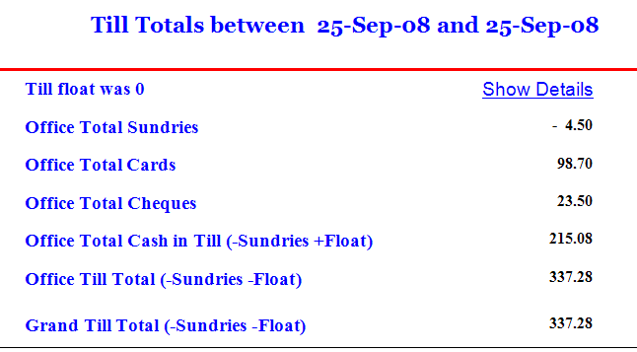

The credit card reading can be checked against your PDQ (credit card) machine, if all payments have been processed correctly then these figures should match. The amount for cheques should be the total of all cheques received for the day

The cash amount should be what is left in your till after removing your float (if you have entered zero). The cash amount will automatically have added or removed any Sundries entered from the Daily Cash In/Out option via the daybook. See below for adding/removing cash

For discrepancies see the troubleshooting section below.

To see what individual staff members have ‘taken’ for any time period, refer to reports:-

You can use any of the following as a reference;

Reports….. Financial…...Gross takings by an employee (includes average spend)

Reports……Sales-Services/Treatments……..Service sales Summary by Employee
Reports……Sales-Products…………Product sales Summary by Employee

Adding and Removing Cash – Sundries/Petty Cash

Steps:

Go to the daybook from the main menu
right mouse click anywhere
choose Xtras....
choose "remove cash or add cash"
type in amount and then press enter
You will now be asked for a description/reason e.g. "magazines", then press enter
The figure can be seen on end of day cashing up and be accounted for, there is also a report
To give you all amounts and descriptions for any timescale.

Reports…..General or Most Used Reports……Cash In/Out Sundries
TROUBLE SHOOTING end of day cashing up

If your end of day totals or money are not correct, these are a few of the things that may help. This is by no means a comprehensive list but may point you in the right direction:-

At end of day it is advised to check the following;

Reports….Products…Product Sales Summary by employee

And

Reports…Services…Service sales Summary by employee

The total of both these reports for the day should match the Grand Total of your

Reports…General or Most Used Reports…Daily till totals by office or department

If they do not match

- Have any payments been made for future appointments? If money has been taken for an appointment ahead of time it will make your till total report/s higher than your two summary reports.

- Have all appointments been put through as paid (made Green) on daybook? If an appointment has been physically paid for by the customer but the appointment has not been made green, the money in your till will be over against your till total report. If a client has left without paying, your reports will be correct (unless you are checking against an ‘expected amount’) but you will still have a pink entry in your daybook.

- Have any monies been removed/added to the till for sundries? Money going in or out of the till must be added to Platinum.
Daybook…right mouse click…Xtras…Add/Remove Cash, enter amounts and descriptions.

- Are you using Vouchers? You need to use the till total report that is Voucher aware,
Reports…Financial…Till Totals – Voucher aware (or if on newer version Reports…Most Used Reports… Till totals – Voucher aware

If your figures are still not matching, always check;

Reports…Financial Investigation…Payment Inconsistency, be aware of any entries in Red. This is showing different amounts have been paid against what was expected for the services/sales provided. It may reflect an over or underpayment. NB If you include tips at point of sale these will show up in Red on this report but are usually very obvious.

If this still does not show anything that may be the problem, take a look at the Payment Inconsistency by day report, this will show if an appointment was paid for on a different day to the appointment. A future appointment may have been paid for inadvertently during the rebooking stage or whilst checking forward appointments for a client during a busy time on the desk.

If a payment was not completed correctly it may have turned Green on the daybook but not registered the payment correctly, there is a report in the diagnostics section called Payment Record Check which will flag these. They need to be repaid (read instructions on the report)
To REPAY for an appointment see below

Some Golden Rules to Also Help:-
1. Do lots of pinks and yellows remain on daybook?
"Appointments must be deleted if a no-show"

The whole daybook must be green before the till total report is run or it will never match the due amounts based reports like the sales reports
2. The card figure from your machine may still differ from Platinum; this is likely to be
due to the wrong payment type selected on the payment screen.

If you have the card receipts, you can tally them with customers that have paid and repay
any that may need adjusting.
See Financial Tracing (Diagnostics)......Payment Inconsistency
To repay:-
Make the appointment pink again (arrived) then repay choosing the correct payment method
and then you can simply:
*right* mouse click on the green appointment in the daybook where you will then see a menu.
Choose Xtras...e-Business....Troubleshooting.....
"Set this to paid for on the same day as the appointment"
This then sets the appointment that was paid for today to look like it was paid
for on the appointment day.

To find for more detailed information/real questions and answers from customers
please see our searchable web page: http://www.xpectworld.net/help.html

REPORTS

How to Print and Export Reports

To print any report:

Go to Reports via Platinum’s Main Menu

Select the report that you require and set the start and end date – standard is the dates are set for the current day.

Click Next

The report will appear on the screen, in the top left hand corner of the page are some small icons, and one of these is a printer symbol
(If you hover with your mouse it will also indicate ‘Print’)

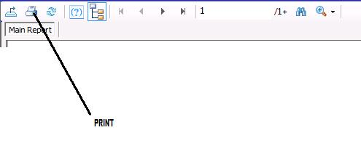
If you click this icon your standard A4 printer window will appear allowing you to print the report – print all or you can select pages from this window.

If you do not have an A4 printer at your business you can email the reports to your home or elsewhere for printing purposes.

Click the first icon, Export report.
(If you hover with your mouse it will also indicate ‘Export Report’)

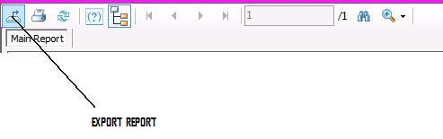

You will then have a window that opens to save the report in ‘My Documents’, crucially you must select something other than Crystal Reports as the format to save the report in – we would recommend PDF.

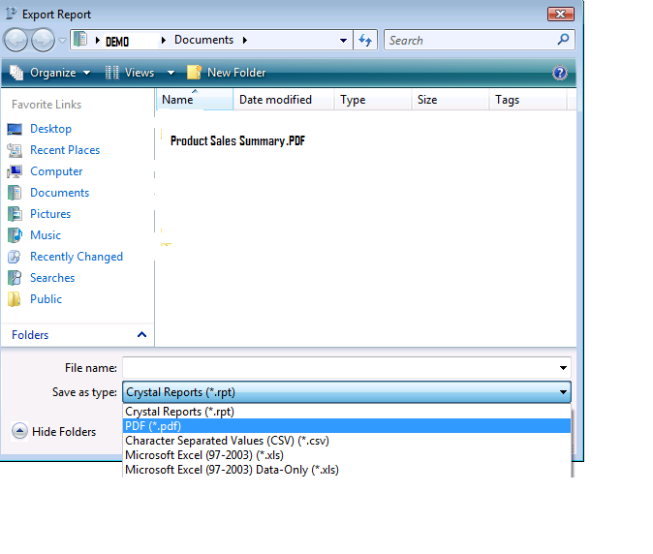
Once saved, these can be added to an email as an attachment, emailed home or elsewhere to print if necessary.

Financial Reports for Accounting

This is a list of reports you may want to use yourself or send to an accountant.

These are purely a suggestion and we recommend that you look through the list of reports and use the ones that you feel are best suited for the results that you need.

SALES:-

Sales-Products…..Product Sales Summary by Employee
Sales-Services/Treatments……Service Sales Summary by Employee

TILL TOTALS/CASHING UP:- - See page 29 for cashing up advise

General or Most Used Reports….Till Totals by Office (or Department if using)

Note. If using Vouchers you need to use;
Financial…….Till Totals by Department - Voucher Aware
Or if on a newer version Most Used Reports……. Till Totals by Department - Voucher Aware

Petty Cash /Sundries;
General or Most Used Reports……Cash In and Out (Non customer Sundries)

IN SHOP USAGE OF PRODUCTS:-

Products…. Product Use By Employee

VALUE OF STOCK:-

Products……Retail Stock Count

Restricting or creating a shortened list of reports that you use.

Sign in as Manager

Go to Reports from the Main Menu

Use the Blue (...) gel button top left

Customise...

Here you can now set up a restricted list for Staff and/or a shortened list of reports for manager.

TIME SAVING FEATURES

Customising the system to your business….easily!

If you Sign in as manager, then go to the advanced menu; which is found on the main menu, then hover or touch the blue (…) button you will get a popup menu saying Easy Setup…..

This allows you to completely customise the application, including enabling security and secret passwords to the system and your till to setting up manager email and mobile phone numbers

Please see section at the end of this User Guide to help you further

Search on Service names and short-names in service list
When making an appointment, when the service list is on screen, either type the exact short-code you have used or type a few letters of the description for the services you are looking for and then you will see a list of partially matching names for you to choose. This saves you scrolling through a big list to choose what you want.
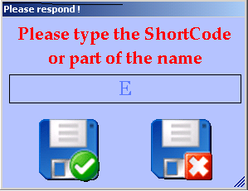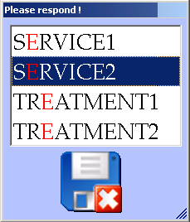

Durations of services are ‘Learned’
Platinum will ‘learn by example’ and once 'shown' on a per employee basis will in future ‘know’ what the start, processing\wait and end times should be.
This is real artificial intelligence; it saves you time because there is no complex setup, saves money as there is no expensive setup costs and also prevents new staff making mistakes.
NOTE: If you re-open and change an appointments duration, this new duration will not be used in future for new appointments. The system only ‘learns’ the durations from the last new appointment created with this specific employee.

Search for products/services when editing
If you go into Services or products from Main menu, using the (…) button bottom right of the screen, you can search for the product/s or service/s you want to edit. Type in the name or part name and it will display all options for you to choose and edit.
Super Fast re-bookings
To very quickly rebook the very same services that a regular customer has;
Click the customers preferred date and time in the daybook diary.
Then search for the customers name as normal.
In the history area which shows the past appointment dates, choose one that has the very same or similar services to what they are wanting this time.
Double left click that date. (Double click)
This will copy exactly the details of the appointment to save you time selecting them again this time. Always double check all the details before going through the payment process

Repeat Bookings

You are likely to have regular customers that come in at the same time each week.

Platinum has made it easy for you to add these bookings in automatically, rather than having to manually add each one of them.

Enter the first appointment as normal.

You then want to copy that appointment

Open appointment, Hold the /\ Shift Button down and Click ‘Move appointment’

Platinum will inform you that you are going to Copy the appointment.
Click Ok.

Then go forward in the daybook to the next time slot that the customer needs an appointment for.
Click the desired cell on the daybook, you will then be asked if you wish to copy that appointment for a number of repeat times.

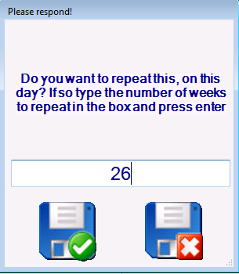

Add the number of weeks you wish to enter that same appointment for.

Top Tip

As tempting as it is, do not enter too many weeks (we recommend no more than 52 - one year) as circumstances can change and you will have to delete/move each individual appointment if necessary

One employee view of daybook for the week
If you click the right mouse on the daybook, you can select ‘One Employee On The daybook Mode’.
This will then give you a drop down of all employees.
Select the employee you need and it will display their week in column format, allowing you to see availability easier.

Seeing a customer’s future appointments when they are rebooking
During the pay process you are asked if the customer would like to rebook.
If you hover over the (…) blue button top left of the ‘rebook 1 to 8 weeks screen’, it will show you any future appointments that this customer already has booked.
This is particularly useful for a regular customer who has many appointments put in ahead of time, any future appointment can be confirmed and this prevents any double booking

Name search on Emessaging
You have the ability to search for a name/s when wanting to bulk send a specific message.
In emessaging list of customers right click your mouse….Search
When name is found, double click in box for message to be sent as normal.

Moving to the Monday of the following week in the daybook
On the daybook the (…) blue button, bottom right of the screen, allows the next Monday to be selected instead of the ‘move forward 7 days’ button >7 and then selecting the Monday of that week.

Showing the ‘history’ of an appointment
If you Right mouse click on any appointment you can see a 'what’s been happening' specific to the appointment. (This will help show any moves or changes that have been made to a particular appointment)

Ability to change the way the customers name is viewed for emessaging
On any emessaging screen, you can right click your mouse and have the option to use first names or surnames only in the list.

Appointment reminder cards from the receipt printer
Save time by not writing out appointment cards. When using the rebook option during the pay process it will automatically print the reminder on your receipt printer. You can also *right* mouse click on the appointment details to print this off if it is a walk-in customer.

One person paying for services for two or more people

Platinum has a multi-customer payment feature to make checking out easier. Hold down the SHIFT key on computer keyboard and click all appointments that need paying for.
A box will appear with the customers names in – the first name is the person who is paying. The name/s below are all the appointments that are being paid for by the first person. If you make a mistake, you can remove one by clicking on the name in the box. Once all names are in the box and you have checked them, click the green tick to continue.

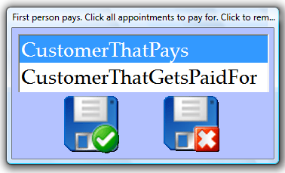

This feature is also available by right mouse clicking the appointment of the person paying and choosing "Multi Customer Payment Wizard"

Discounts easily selected
You have two choices for discounts of services. As with products you have the discount boxes at the bottom but this time you can choose from a drop down menu the % discount you want to make it faster to choose. If you just want to select one service to discount, hover the mouse pointer over the service price and right mouse click, choose a discount and then *CRUCIALLY* you must tick the name to make it red and calculate the totals.
Customer contact details
If you hover your pointer over an appointment it shows a popup with customers contact details with short codes and the appointment start time.
** If you have security in place to hide customer details, this pop up will not feature **
Email Template Changer
You can search for a word in your email template and replace it for another one easily in your email templates.
Easy Setup...e-Messaging...Setup...Easy Email Template editor

This allows you to type a word and replace it with another word. e.g. if your name or your contact number changes.

Week book
On the week book, clicking the date header label will open that daybook. You can also choose an employees name to just show that employees appointments. This helps with specific requests for specific employees at specific times.
Firstly click the top left blue gel-button (...), choose the requested employee, and then click the date header of the daybook to open. This makes booking requests much faster.

Setting daily start and end times
You can alter start and end times for each day to coincide with different opening hours. Go to more set up from main menu, go into Roster, using the (…) button in the top left hand corner, select the option ‘I want to change the opening hours by day’. Select your daybook option of 15 or 5 minutes and a scheduler screen will appear. Choose the day and the opening hours (its 24 hrs so, for example, 5pm is the number 17)

E-Mail address searches
Platinum detects an email address and will search if it detects a @ is typed in the name search box. The full email address must be typed.

Appointment copying – on same day in daybook but to different employee
DRAG an appointment as if to move it but *before* letting go of the left mouse button Hold down the SHIFT key this will COPY the exact same customer appointment you can then assign different services.
Names displayed on daybook or customer lookup
You have the option to have your customer’s names shown as full name, surname or firstname, this can be altered as and when you need to by clicking
More Set Up… Easy set up…daybook…Customers
Multiple rebooks
If you have used SHIFT-Copy, on appointment details screen, then Platinum asks you if you want to repeat book-"how many weeks to repeat this booking?"

Skype Compatibility

Platinum is compatible with Skype, If you have a Skype account set up via www.Skype.com and your Skype is installed you can hold SHIFT and click on any telephone number in a customer’s profile. Platinum will automatically connect with Skype and dial the number.

Save e-Messaging Marketing Messages to re-use again
If you are happy with your marketing message you can save it for future use by clicking the (…) button. In future you can then change it slightly and re-send it. Saving you time looking for that effective message.

In this area you can search and preview your eMessages from your list of templates. The 'insert' option allows you to insert text into the body at the cursor position. This allows snippets of commonly sent text to be put together into one message very quickly.
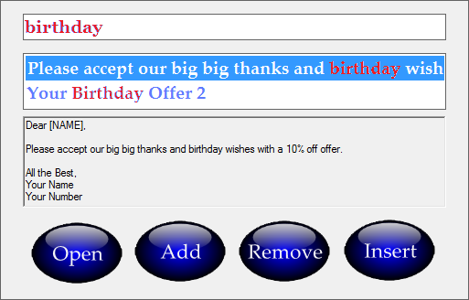
The top box is for the search words e.g., birthday and by pressing the 'ESC' key this will reset this search. (see top left of the computer keyboard for the ‘ESC’ key)

Highlighting an important appointment or one that needs approval
You can make an appointment RED if very important - right click on the appointment in the daybook then click ‘Xtras’…colour code…RED.
Very Easy Licensing
Platinum uses a web based license renewal. When your license is due for expiry (all customers with Platinum, will have a license in place) you will be notified on your screen every time you open Platinum for a period of 7 days before expiry. By using the @ button (bottom right of Platinum sign-in screen) this will allow the license to be renewed quickly.
2 Way Text Messages
Instead of calling each customer to see if they can make their appointment you can optionally mobile phone text-message them. They can then reply with a ‘Yes’ or’ No’ – If ‘No’ an email will be sent to you and their appointment will appear red in the electronic diary-daybook. It can then be given to someone else. There is an extra charge from our provider for this service.

Tax compatible for worldwide customers
All prices can include tax or exclude tax and add it at the till, this can be set up to be compatible for different countries, i.e.: UK includes tax, Canada/USA excludes tax. Where required the tax amount calculations and breakdown can appear on customer’s receipts.

Quickly Dial Customers Numbers and Lookup Addresses - *also see Skype above*
From the customer profile you can quick dial phone numbers by holding down the SHIFT key on the computer keyboard and clicking any telephone number. Then click Dial on the next window*. This saves eye strain, wrong numbers and speeds up any calling you do to customers e.g., for confirmations. This works the same with the postcode box to see where people live on a convenient map.
*Voice modem hardware needed which comes with most laptops and is cheap for desktops.

Customer messages
You can email, mobile text message or send postal letters to customers, for example, instead of tracking loyalty points on paper cards. Then select customers to send letters to. You can track loyalty automatically and then generate loyalty letters automatically to send out.

Invoices and receipts
If you decide not to buy a receipt printer but a customer needs something for their personal accounts you can print off a professional invoice on an A4 printer. This saves you hand writing one, is faster, more accurate and looks more professional.
*Right* mouse click on appointment details. (Requires setup at no extra cost)

Membership Management:

Expiry dates can be set and automatic warnings of expiry shown.
From your customer profile hover over the top left (...) button...e-Business...Membership.
This is checked on making appointments giving a count-down a month before expiry.

Expiry reports (All customers via the main reports screen or one customer via the above area).

Membership expiry-warning-mode is enabled automatically at 30 days if you set any customers expiry date, but is configurable.
A drop down of expiry date options is there for easy selection of 1 week, 1, 3, 6 and 12 months.

More Advanced Topics…

There is a lot more information on the help website, it has questions and answers from actual customers, you can search this for answers to your own questions.
Click the ‘Help Me’ button on the main menu or visit www.xpectworld.net/help.html

To Delete

If you scroll to the far right of most of the 'grid or excel style' windows, (services/treatments screen, products screen and employee screen, you will see the 'delete' column.
Double click the empty tick box so that a black tick appears.
Go back to the main menu to save, at this time it will be flagged as deleted and will not show again in your data.

Tip: To see all customers in an excel style grid for deletion; hold down the SHIFT /\ key and click the customer lookup button on the main menu.
Still holding the SHIFT/\ key click ‘Show All Customers’, you can then scroll along to the far right and delete any required (NB, if you do delete you are also deleting any history, so if a duplicate name for example, make sure all history is transferred from one customer name to the other)

The SHIFT key sits between CTRL and CAPS LOCK bottom left of your physical computer keyboard.

TIP: You may want to add some extra security into Platinum to control things like deletions. All of this can be set via easy set up:-

More Set Up from main menu……Top right hand corner blue (…) button…..Easy Set Up……Security……..Staff Access. See Page 61 for further information on set up

If you have deleted a customer by mistake

SHIFT click customer lookup for excel-style grid, hover your mouse over the top left (...) choose; Xtras..."Show deleted as well" (Search Disabled)

You can then ‘undelete’ by removing the tick in the box in the delete column.

Moving/Cancelling multi appointments with same Customer

If a customer changes their appointment to another day BUT has more than one appointment booked in, the system will not automatically move the 2nd/3rd appointment to the same times on the new day as it can lead to double booking. Once the first appointment is moved a list is shown of the other appointments from ‘that day’ and they can be moved manually if required.

When deleting (customer cancelled) if there are other appointments on that day the system will warn you to investigate them/ask the customer if they wish to cancel those also.

To Change the Customer associated with an Appointment.

The system has the ability to unlock and change the customer that is associated with the appointment. Right mouse on their profile. This is useful to convert a WALKIN to a real customer once they are in and you have time to take their contact details
Changing of one security password to another

This allows for keeping your system more secure, or maybe after a change of staff etc.
More set Up…..Easy Set Up……..Security………Secret passwords

Buy 1 Get One Free, 3 for 2 Offers in Product Sale

Select the number of products required and place them in the shopping basket, using the SHIFT key click on the last product selected. It will ask you what new price you would like to enter. Enter zero and this becomes your ‘free’ product. It will still register in your stock control but the customer will not be charged.

Selecting your own colour scheme for Your Platinum.

You can brand Platinum in your own way by selecting the colour scheme you prefer. On the Platinum sign in screen, select the (…) blue button bottom right.
Select ‘Colours’
Select ‘Set Up My Colours’

You can now select from the list available.
There is also an option to reset back to the original colour scheme.

Setting Your Room Numbers with a Name.

You can choose to rename the room numbers to something more personal, the first 2 characters are shown on the daybook.

Select ‘More Set Up’ from the Main menu
Hover over (…) Blue button top left of screen
Select ‘Easy Set Up’
Select ‘manage’
Select ‘Rooms’
Select Room number to be changed
You can now add or change text. – This can be repeated for all rooms required.

Adding new stock to existing stock
Platinum has a utility to add newly delivered stock numbers to existing stock level - 'number in stock'. Simply beep the barcode of the new product and type the number of new items that have been delivered. No more calculators or mistakes.
Click; More setup...Easy setup...manage...product...deliveries...

Details of payments on till totals reports

These reports allow a drill down on totals to display all payment details.
(Hovering over the totals, it will show a magnifying glass mouse-pointer, double click and a list of payments will be displayed) If you get a security message just tick the box and click OK.

Security and privacy to stop theft of Customer Details

A password can be set up for access to the Customer profile. If this added security is set up, the contact details that show whilst hovering over an appointment in the daybook will be switched off.
See More Setup…Easy Setup...Privacy

Security for opening cash drawer

Right mouse on daybook… Xtras...'open cash drawer' can optionally be Passworded
Added security for ‘In-shop’ usage
You can set a secret password to stop fraud on the in-shop product sale button
Click More Setup…Easy setup…Security…Secret words
See Page 61 for further information on set up
Taxes
The tax on product and services has local and country rates, for use with zero taxable items. The receipt can show non-tax, net tax and actual tax repayment values if required

Backups
The backup gets copied automatically to all possible drives meaning no setup is needed.
Platinum will automatically back up to a USB pen drive if plugged in.

** We recommend buying two pen drives and swap them weekly, keeping one at home. To backup, simply close down daily at end of business, then once a week, take one home and copy to another computer for added assurance **

**Your backup will also save this month’s appointments report in case of computer failure**

In a disaster recovery situation, we can only restore data to the last available backup.

Multi Departments

This feature allows you to have more than one electronic appointment book (paper diary), see above. Customers can have appointments in more than one daybook but when paying they will add up the total price for all appointments that day.

This is perfect for you in the following circumstances:
- You have more than 8 employees who can be grouped for simplicity
- You supply different types of services or treatments and want a separate appointment book for each of these ‘departments’
- To setup Multi-Departments, see Page 53

Multi Level Pricing

The multi-level pricing feature of Platinum allows you to have a different price for a service for each employee. Platinum automatically enters the correct price for the service depending on which employee the appointment is booked for. This feature is perfect if you have different levels of employee i.e. Junior, Senior, Manager – all with different charges for services.

To setup Multi Level Pricing, please click ‘Help Me’ on the main menu or contact Platinum help.

Courses

During the payment process your staff will 'optionally' be prompted to 'up-sell' a course of a service or treatment based on whatever they just had. This directly increases your profits.

Platinum knows if they do not have a course for the service they just had done and will offer one.

Platinum knows how many they have left and will reduce them each time they come in and use the course. To do this you just ‘pay’ for a course using the course button.

This can be switched off if not needed but is a good reminder to ask customers
if they want to buy a course of whatever they just had 'as a one off appointment'
- Keeping them coming back for more.

When using up each of a customers 'course credits' you simply click the 'course button' instead of cash/cheque/credit card.

Courses will only work on a one-to-one basis (1 appointment to 1 course).
If a customer is in for two services, and they have courses of each service, you must put them in as two separate appointments.

Viewing how many courses remain

If you right mouse click in any blank space on the customer profile screen you will see:

Courses.....

Here you can add a course of any service you have,
Edit the 'number of credits left' and type of courses
and also show a report on how many 'course credits' a customer has left.

You can also see all your customers’ course-credits from the report "Customers"..."Courses of all Customers"

Time based courses (bulk buying of minutes)

Courses can also be sold the same way as products (through the shopping basket) and are associated with a customers account.

Sessions are booked the same as any other appointment and minutes used are automatically deducted from the customers total remaining as they use their credit-time up.
Vouchers

Platinum can create vouchers and allows customers to pay fully or part-pay with a Voucher.

If you have a receipt printer you can even print out vouchers with a personal 2 line message on each.

To pay with part voucher and part another payment (like cash)
When you are about to select the payment type on the screen that tells you how much the customer needs to pay:

Tick the mixed payment tick box.
(or hold down the shift key on the keyboard the shift key is the long key below "Caps Lock" and above "Ctrl" key the shift key must be held down all the time

Then click the Cash button (if it is a part cash payment)
you will notice that the cash button shrinks slightly
and with shift key still held down
click the Voucher button
you can now let go of the shift key on the keyboard

This will then ask about how much each amount is
e.g.
How much on cash e.g. you could type 20
How much on voucher e.g. you could type 20

To setup support for Courses and Vouchers, please click ‘Help Me’ on the main menu or contact Platinum help

Swipe cards and finger print identification

You can optionally have finger print access to the system by only certain employees and the system is magnetic card or swipe card compatible for security. There is a cost involved.

Refunds (There is much more information about refunds on the help page on our website.)

Imagine this situation:

Yesterday you sold a product for 20
today it gets returned and you take 20 out of the till to refund the customer
you must tell Platinum or the till report at the end of the day will show 20 less than it should

Steps:
Go to the daybook from the main menu
right mouse click anywhere
choose Xtras....
choose "remove cash"
type in 20 and then press enter
type in the reason e.g. "A refund of 20 due to wrong purchase", then press enter

Tab Usage

Customers can have a running tab. This means that trusted customers can have services or products and hold a credit value with you. This can also be used to support any pre-pay system that you currently run. To use tab simply chose tab instead of Cash on the payment screen. The current tab value can be seen from the ‘customer profile’ page2 (click ‘More Details’). Read a lot more on the help web page or contact Platinum help for more information.

Chair or Space Rental

Platinum can record how much money temporary employees owe for chair or space rental and produce a report to show this. To setup Chair Rental Tracking set the daily rental amount in the employee record area, roster off employees properly and run the chair rental report from the employee report group. Contact Platinum help for more information.

Pin Entry Security

You can optionally setup each of your employees with a pin number, once you are set to pin security mode, each employee needs to type their own pin number to open the till or to enter the system. Their actions are then recorded by the system for you to later examine. This can also be setup to just secure the till opening if needed.
You can then run the “General” or the “Most Used Reports.…What’s been happening” report and see each event during the day and who did it.
No more “It wasn’t me, honest!”

See Page 61 for further information on set up

Need to ‘undelete’ an employee?

If you have deleted an employee in error. Their column and any appointments will have disappeared;

Go to Employee screen, click blue gel button top left, Xtra’s, Show Only Deleted Employee.

This will now show only deleted employees, to bring any back, you need to scroll to right hand deleted column, click on the column to remove the tick. The employee will now appear back on the daybook.

Top Tip: If something disappears make sure you have not set it to the wrong department, scroll to the far right on the edit screen to see.
Another thing to check is you have Y in the column ‘show on daybook’

A Selection of Extra Areas
You May Want To Set Up

More Set Up from Main Menu
Blue Gel Button (…) Top Left
Easy Set Up

Below are some of the options that are available to set up for your business:-

DAYBOOK

Display how customer’s names are seen on daybook
Switching departments on or off
Daybook look, being asked about re-bookings and moving appointments

EMESSAGING

Set up of emails and SMS text messages (You do need other details to be set up but once done, here you can make changes)
Proactives, Reminders etc.
See section below (page 47) – How to send SMS text messages and Emails from Platinum

POINT OF SALE

Set up of cash drawer, receipt printer, bar code reader, customer display
Y or N to paying early, arriving early, type messages
Setting mixed payments
Removing Processing/End Times
Set up staff/customers record for Quick product Sales
Switch on/off up-sell of courses and products
Tab – showing on customer look up.

MANAGE

Customers – Profile. Loyalty, Voucher
Department – add, rename, delete
Employee – accountable for QPS and In-Shop.
- Data Entry. Must take contact details
Products – Stock Levels and Remove from basket

Managers end of days totals and stock levels
Staff Access to tools and set up areas
Exit Only from Exit icon (not the cross top right hand corner-no back up)
On Screen Keyboard

PRIVACY

Hide customer contact details from employees
Send day’s appointments to employees via email

SECURITY

Pin Codes
Secret words
Sign in access
Manager only can delete paid for

See Page 61 for further information on set up

E-BUSINESS

Customer – currency converter, postcode lookup
Finance – accounting, tax, batch reports e-mailer
Pay Process – tab reduction

NB: This is only a selection of the main items to consider, under each heading you will find other options if you need them.

More Set Up from Main Menu
ROSTER
Blue Gel Button (…) Top Left

Setting of Business opening hours. (Each day is done separately)

Roster allows you to ‘remove’ employees from daybook for days the business is closed, their holidays or days off if part time workers etc.

Rostering of Staff that are always off on certain days of the week.

CRUCIAL:-

After any change of settings for the above – you must exit and re-enter Platinum for the changes to take affect.

Department Set up

If you need financial segregation, or simply want your staff in different departments for the day book, then you need to set up in the following way:-

Go to More Set Up..Daybook.. Departments… switch on departments

Make sure all is set up as you need it in the main daybook (department 1) as this will be what you are cloning (copying)

Go to the Department clone utility.. More Set Up…..Blue Gel Button (easy Set Up)….Manage….Departments….Add new department by cloning.
Follow on screen instructions.

Clone Department 1 as many times as you need, and with the new department names.

These will now be in a drop down on the daybook.

Next you need to rename Department 1.. Go to More Set Up… Blue Gel top left
(Easy Set up)….Manage….Departments…Rename a department.
Follow on screen instructions.

Now you need to go to the employee screen. Each time you clone, it duplicates the employee names that were found for the original setting. You need to move the employees to their new department and delete any that are no longer required.
There is a column showing department if you scroll to the right, click on this name and you will be given a dropdown to select the department needed.
(For ease if any future changes, we would recommend renaming them ie. Jane 1 and Jane 2 for those you are deleting)

If any departments have different opening hours or are not open on a particular day you will need to go the Roster and set the hours for that department.

More Set Up… Roster…Blue gel button top left… Set opening hours

Lastly you need to point the particular services to the correct department. In the services list, if you scroll to the right hand side you will see the department, click on the name and it will give your dropdown to select the department that the particular service should be for.

Naming the Price Columns for Services/Treatments

To rename the headings of the pricing level columns in Services/Treatments

Click More Set Up from Main Menu
Go to top left Blue (...) button

Easy Set Up…Manage…..Services/Treatments….Price Range labels 1-8

Add a name to each number as required.

There are 8 columns that can be used/named

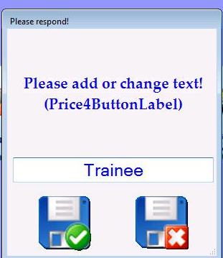

You can add as many as you need before restarting Platinum but you must restart Platinum when you have finished, for the names to be saved.

You will see the saved headings when you go to Services/Treatments master list from the Main Menu.

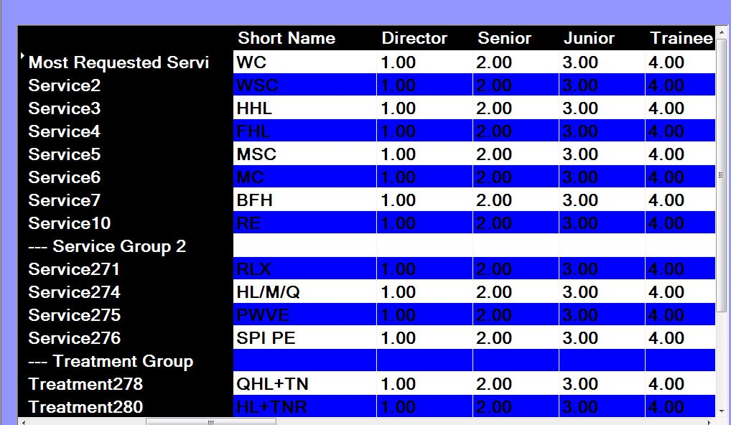

Setting Up SMS Messages Within Platinum

You currently can only use the following instructions if you use our recommended SMS provider Icetrak. If you are choosing to use another provider then please speak to us first.

Once you have made the request for SMS Text messages to e implemented, we will send your details to Icetrak. They will send you an email (generally within 24 hours)

In the body of the email will be your account Username (generally your email address) and a password. You will need these to hand when setting up.
Also with the email is an attachment headed

The Set up should take you no more than 10 minute and is very easy.

Step 1.

Go To Easy Set Up….Emessaging…..**For Mobil Phone Text Messages First Set Your Name and Telephone Number Here (Click Here) **

Follow exactly what it says and add your Mobile Number for end of day figures, Your salon Short name and your Salon telephone number.

Restart Platinum

Step 2.

The attachment that is mentioned above now needs to be run.

Open the attachment and click on the link

http://www.xpectworld.net/mobile/PlatinumIceTrackSetup.html

Follow what the instructions say and

Click this link to run a program to very easily setup text messages with Platinum.

When you click the link you will have a RunMe.exe

Please double click this and fill in the details required in the form that appears on the screen:-

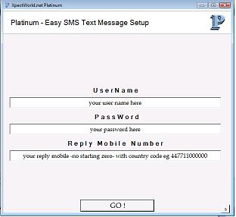

The username and password are those that are given in the body of the email from Icetrak. Add your Mobile Number as stated.

When all is complete click GO!

You will see Working…… And then Done

Restart Platinum

You can now test a message to yourself and check all is working OK.

If not already done, you need to add your own name and mobile number to the database (New Customer Screen)
By clicking on the e next to the mobile number area in the customer profile, this will bring you to the emessaging screen.
Add a message into the small box at the bottom of he screen (This is where Text messages are entered, the large box is for emails)

Click Next
Tick the TEXT box adjacent to your name
Click the Green Tick at the bottom of the screen

Your message will now be sent – has it been received on your phone (This may be a little slower than mobile to mobile text messages so do give it a little while)

If tested OK

Step 3

Switch on Reminders

Go To Easy Set Up……Emessages….Reminders

Set How many days Ahead Do you want Reminders Sent – usual is 1 day

The standard time is already set for 11AM.. Only change this is you need the reminders to be sent out at a different time in the day.

You now need to switch the reminders ON

Reminders…Reminder Text Messages….Switch On Reminders

Restart Platinum

You will see the Reminders are set in the top bar of Platinum alongside the salon name once you have signed in.

You can switch on any other Automated Text Messages that you may require

Easy Set Up….EMessages

Happy Birthday
Come Back and See Us - Proactives
Thank you For Coming
No Show

IMPORTANT – You Must Be Connected To The Internet For SMS Messages To Be Sent.

EMESSAGING – Sending SMS Text Messages and Emails from Platinum

EMAILS
For the feature to be set up in Platinum, you will need some information from your Broadband provider. This is known as the SMTP details; Username and Password of your account. This account must be active (you can receive emails to and from the account)
You may need to call them but often it is in your Broadband paperwork.

Important:
We suggest that you request an email address that reflects the business name as it will be what all your customers ‘see’ as the From: address when in their inbox.

Mobile Phone Text Messages (SMS)
We recommend a company called Icetrak (we will contact on your behalf) who will provide you with an account and a few trial text messages as an introductory offer. The email they send will include easy set up instructions for Platinum. (If you choose to use an alternative SMS provider, there is a charge for set up and compatibility will need to be confirmed)

Using it to contact your customers…

The eMessaging button from the Main Menu allows you to set up templates which you can reuse at any time, type your email or SMS and using the top left (…) button you can save.

Once the feature is set up and you have a template you wish to use, you can email and/or SMS in a number of ways:-

1. To one person directly from their profile:

In a customer’s profile, click the ‘e’ to the right of the mobile number.

2. To everyone on your database:

The eMessaging button from the Main Menu; this allows you to send to all customers, if a restriction is in place to numbers from your broadband supplier you can choose to send small groups at a time. (Click your right mouse button for a menu with options).

3. From customer related reports:

Use this to target groups of clients by holding down the ‘CTRL’ button when clicking Next to run the report. When the report is on the screen with a list of customer names and contacts; click ‘eMessage them’ from the top right hand corner. Once the template is selected, you can send to all names that appeared on the report.

There are a number of options for emailing also available from right click of your mouse on the list of names you are sending to:

BCC – you can send a copy to another person and their email address will not appear.

Attach a document – You may wish to add an invoice, Word document, PDF newsletter, etc.

There are a number of messages that can be switched on to be automated from Platinum;
Reminders, Thank you for Coming, Happy Birthday, No Shows and Pro-actives.

Marketing Ideas for EMessaging

These marketing campaign plans are perfect ways to potentially expand and grow the recurring client base.
Here is just a sample of ideas that you can use your emarketing for:

- X amount off services/treatments for new clients

- Pre-book discount - Make sure they return by giving them an incentive to pre-book their appointment.

- X Off Next Service: Every now and then, you need to make your clients feel special. There’s no better way than passing on some savings to make sure they come back to you.

- Recommend a Friend Promotion: Don't just ask for referrals; reward your client for bringing a new business through the door.

- X Off on Your Birthday: Give your customers a gift they can appreciate. Your clients will want to treat themselves to your services, and with the discount, it’s the kind of birthday present clients will tell their friends about.

- Free X gift voucher with the Purchase of an X Gift voucher: Your clients will love this idea. Not only are they buying something for friends or family, they’re getting a gift for themselves

- X Off on Product Purchase of X or More: Your profit margin on products is high enough that you can still make money when you offer discounts. It's also a great incentive to get your customers in the shop for services/treatments and trying out your products, and if they like it, they will return for more.

- X% off an Additional Service: This is a great way to up-sell your clients. If they’re already there, why not give them an excuse to indulge more.

- Introduce a loyalty scheme (automated in Platinum)

- Buy two, Get one free

- Book Off peak and Save Money

- Birthday Gift Voucher

Please Note:- If you have customers that would not want or need to receive the auto reminders or any marketing, you can ‘remove’ them from emessaging.

Go to their profile and in the middle of the screen you will see a square ‘box’ for Reminders and Marketing… un-tick any or all of the small boxes so that messages are not sent.

Platinum Security Set Up

There are many options for security set up within Platinum. You need to decide what will suit your needs best. (We recommend that you consider the options before attempting any setups in case you lock yourself out of the system!)

Please always read the onscreen instructions carefully!

All options can be found in Easy Set Up….Security

The main options are:-

Sign –In

The standard set up is a manager sign in and a staff sign in. The staff sign in automatically restricts access. Manager has access to all.

Staff Access

You can restrict access to the ‘Set Up’ area (this is all set up, the main services and products master area) and The ‘Tools’ area, (this includes reports, emessaging reminders etc.)

Passwords

You can restrict access further by using passwords on a number of screens/actions.

Passwords can be set for :-

Emessaging access
Employee area
Product area
Reminders access
Reports access
Roster access
Services area

Customer Lookup
In-Shop usage
Open cash Drawer
Appointment cancelling

NB: Crucially, you need to remember any passwords that have been set.
If necessary to give the passwords out, be restrictive as to who has them, it is no point having a security set up if all staff know all the passwords!

Pin Code Entry

These can be set up for a number of uses;

- Seeing ‘who has done what’ - all is recorded in the ‘Whats been happening’ report.

- Time keeping, with a pincode staff can clock in and out of Platinum to record their hours.

- If an unmanned desk, it gives you added security from data theft as you can set the system to ‘lock’ after X seconds of no usage and a pin code is needed to re-establish access.

Important:- Before switching on pin code security, you must set all pincodes in the Employee screen (you must be signed in as manager)

You can then switch on pin code access and select the time you want before the system locks, this is from the easy set up… security area.

We would advise a pin code of 4 characters only as easy to remember.

To ensure this set up works as it is designed for, it is important that staff are not aware of each others pin codes so access to the employee screen must be restricted.

Hardware Set Up Page

How To Plug In a Cash-drawer, Receipt Printer etc.

NB: Drivers must be installed before plugging in any hardware


Show me a USB lead plug:-

Connect the cash drawer to the receipt printer using the thin lead
(RJ11 plugs at both ends)

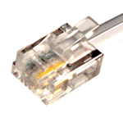
Show me an RJ11 plug lead to connect a receipt printer to a cash drawer:-

Show me an RJ11 socket found on the back of a receipt printer and a cash drawer used to connect them :-
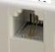

Hardware Trouble Shooting

Whilst we at Platinum are not responsible for your hardware (this lies with your supplier) we of course will always try to provide guides to help where we can to reduce costs to you.

A number of hardware issues can come up and can be easily fixed by you; here is a short but simple ‘run through the basics’ of the most common ones, before having to contact your hardware supplier.

Important:- With any hardware (pc, printer etc.) that suddenly stops working, always try a restart of your computer before doing anything else. (From Start – shutdown/restart)
This actually cures 95% of all issues! Especially if the pc is not closed down at the end of each day which is not only crucial for the smooth running of your pc but of course Platinum does need to close at the end of each day for a backup.

Receipt Printer

If your receipt printer stops printing, check all cables are plugged in correctly (as above) and have not been dislodged or worked loose.
Is the printer in Ready mode (usually a green light) which shows the power is still going to the printer?
Is there still paper in the printer?
Is the paper jammed?

To check status of your printer on the pc:-

In Vista/7 - click the bottom left orb-circle, type: printers and press enter
In XP - open the control panel - Start...Settings...Control panel...printers and faxes

Is the printer showing ‘Ready’ or has it been switched to offline?

Try a basic printer self test:

Switch the printer off
Hold down the feed button on the front of the printer
Switch the power on
It will do a test; the results can be looked at to see if it is working ok.

Does the USB socket work you are plugging into. Can you plug in something to test that-like a USB pen drive?

If all of the above is ok, can you do a Windows test print? (as above).
This will prove that the printer works OK outside of Platinum.

Cash Drawer (printer working ok)

If your cash drawer does not open, again check all cables in case one has become dislodged. Is anything jamming the drawer – Can you open with the supplied key?

Computer;
Black Screen

Is the screen switched on? (Someone may have switched it off and although the pc is on, your screen could be switched off, look for a power button)

Computer Security

Always install reputable anti-virus software on your business computer, a free one that we would recommend is Microsoft Security Essentials.
http://www.microsoft.com/security_essentials/

However even with anti-virus software on your computer if your staff open attachments and browse the web and install software they can easily, accidentally, let viruses take control of your computer.

In the unfortunate event of a virus or things not running as they should on the computer, we do offer a clean-up service for a small charge, please contact us for further information.

You can also try running a number of things yourself, we have put together a few key items:-

http://www.xpectworld.net/Util/ComputerFix.html
How Do I Proceed If I Want To Use Platinum?

Just Software?

If you just want the software on an existing computer for a less expensive start, simply download the trial from our website and we will invoice you accordingly (Purchase or Lease)
The trial is a full working version; you just need to set it out of Demo Mode (see page 5)

Full system?

You may wonder why our systems are a lot less expensive that other quotes. It is simply because, with our full guidance and help, you buy direct from the supplier and cut out the % to the middle man. In all cases the model numbers are exactly the same and up to 100% cheaper as you are buying directly but with the same guarantee and support.

The Simple option?

If you want a full system you can simply tell us and we can get the suppliers to call you to take a payment, we even send them your address so you do not have to repeat it, it is extremely simple.

The D.I.Y. Option?

You can however call our supplier directly yourself, here are their two contact details, please quote that it is for Platinum Software. (Once again if you let us know we can do all this for you and get the supplier to call you directly)

Any modern PC computer will do but please ask us for the specifications of the hardware that we recommend.

If you are looking for just a pc box (cpu/hard-drive) or a full system – all hardware:-

Alan Smith
Lauren Business Systems and Services Ltd
0845 680 0019 - asmith@xpectworld.net

If you already have your own pc:-

Extra Point Of Sale hardware like Touch Screen, hand barcode scanner, cash drawer and receipt printer and consumables like till-paper rolls.

Andrew at EPOS Store - 0845 644 7809 - sales@epos-store.co.uk

